Name: Date: Period:
Alexander the Great Discussion Questions

What were the leadership qualities of Alexander the Great?

GOOD leadership qualities BAD leadership qualities

- 1.

- 2.

- 3.

Who was Alexander’s tutor? How did having this tutor help Alexander?

___________________________________________________________________________

___________________________________________________________________________

Who was Alexander’s hero? How do you think having a hero impacted Alexander?

___________________________________________________________________________

___________________________________________________________________________

___________________________________________________________________________

What are some legacies left behind by Alexander the Great?

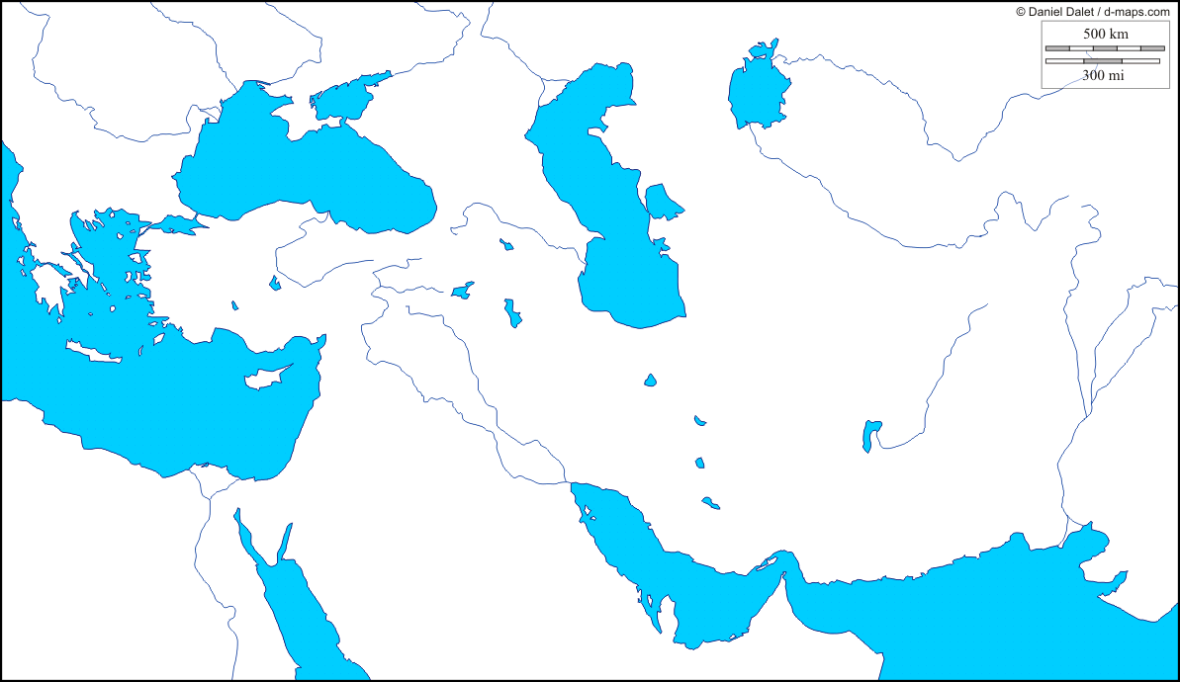

- Color in the territory conquered by Alexander the Great (use page 176 to help you)

- How many continents did Alexander visit? Name them:

- Label the following locations: Greece, Troy, Alexandria, Persia, Egypt, Athens, Sparta

- Alexandria became an important Hellenistic city. What does Hellenistic mean?

- Why was Alexandria so important?

- Name 3 famous Alexandrians, and explain why they became famous

