**Name__________________________________________________ date____________class period____**

***Blizzard Bag Assignment #1 7th grade art***

**Look through old magazines or pictures on your computer to find examples of the Elements (ingredients!) of Art below and paste them in the appropriate sections. Explain or indicate how your example demonstrates the element of art. (14 pts. 2 pts. each. 2= proficient: appropriate example w/explanation or identification. 1=near proficient: appropriate example attempted, no or inaccurate explanation or identification. 0= not evident: no example or example does not demonstrate understanding of concept).**

* **I can demonstrate understanding of visual literacy, illustration, and graphic communication by identifying elements of art in use.**

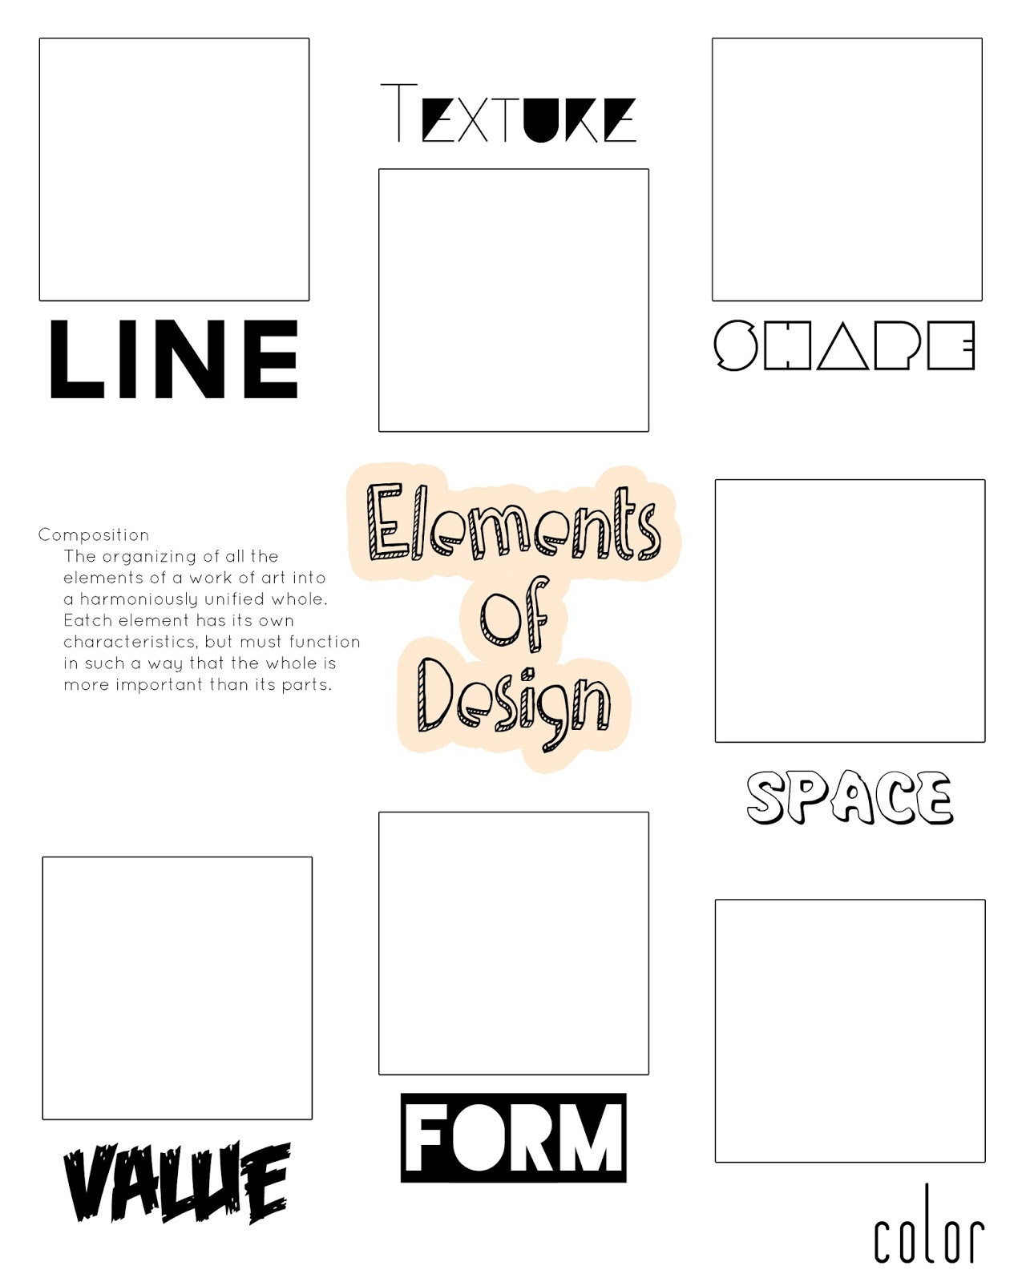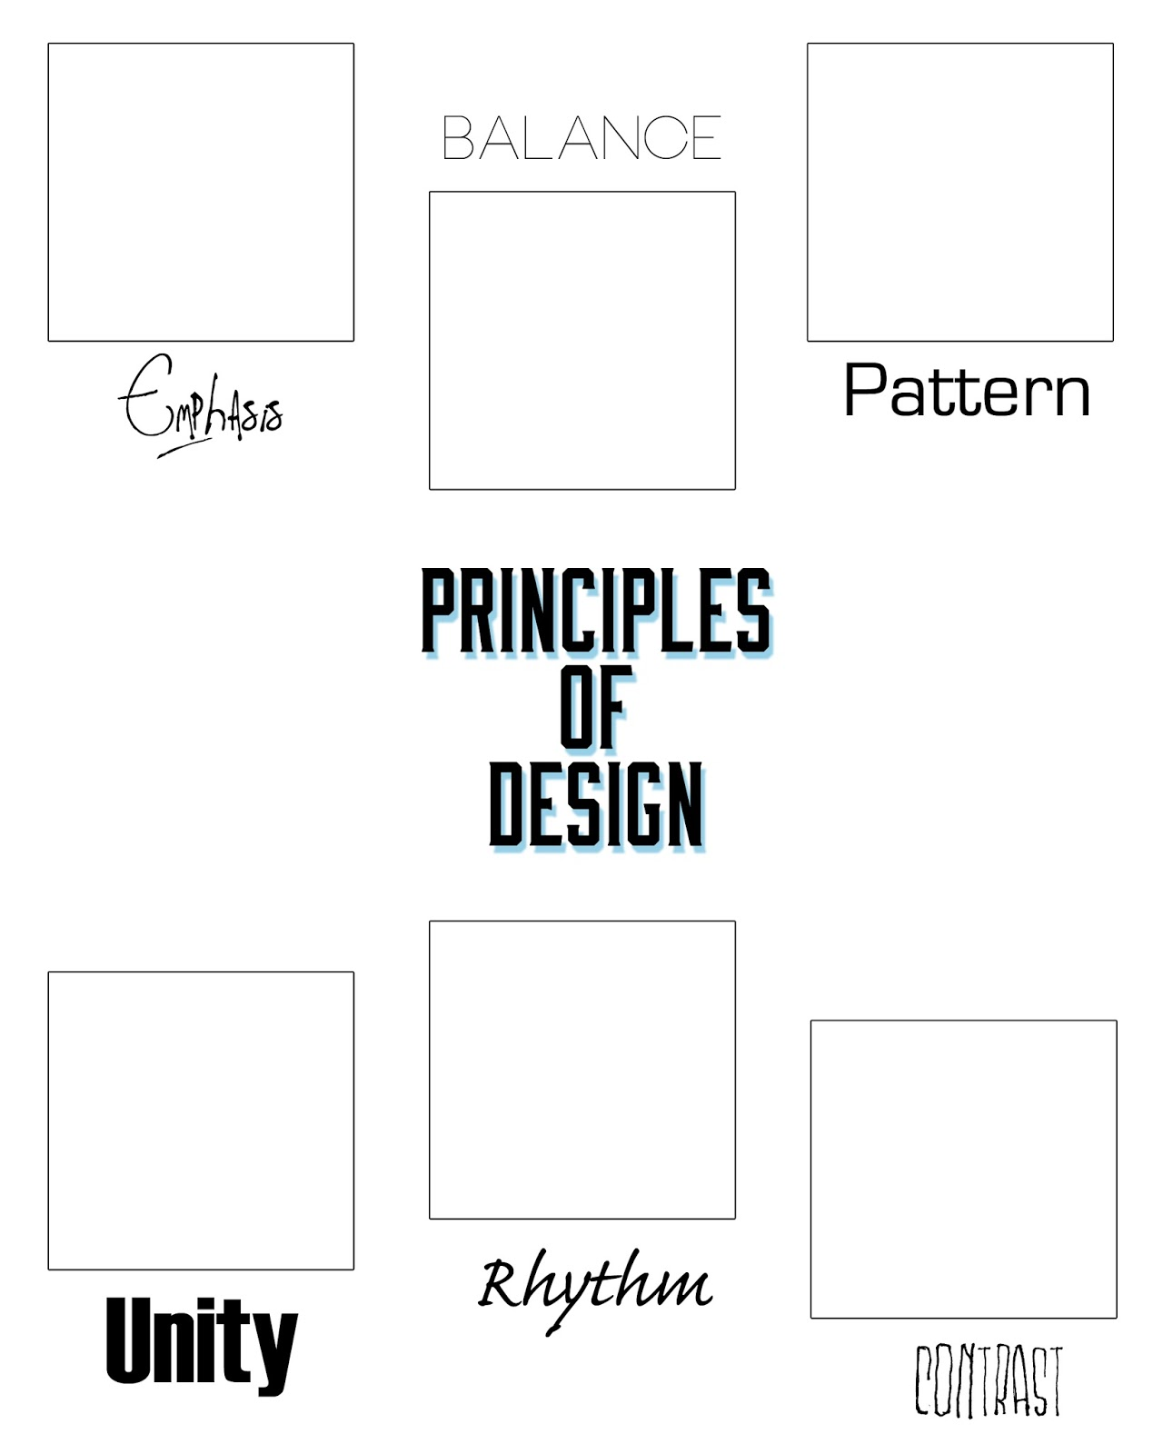

describe._________________________________________________________

real or implied?

explain._________________________________________________________

describe._________________________________________________________

describe._________________________________________________________

geometric or organic?

geometric or organic?

**(ingredients!)**

describe._________________________________________________________

**Name__________________________________________________ date____________class period____**

***Blizzard Bag Assignment #2 7th grade art***

**Look through old magazines or pictures on your computer to find examples of the Principles (recipes!) of Art below and paste them in the appropriate sections. Explain or indicate how your example demonstrates the principle of art. 16 pts. (2 pts. each. 2= proficient: appropriate example w/explanation or identification. 1=near proficient: appropriate example attempted, no or inaccurate explanation or identification. 0= not evident: no example or example does not demonstrate understanding of concept).**

* **I can demonstrate understanding of visual literacy, illustration, and graphic communication by identifying principles of art in use**
* **I can examine designed objects and identify the processes and decisions made to produce them..**

describe._________________________________________________________

**Variety**

**Movement**

describe.________________________________________________________

symmetrical or asymmetrical?

describe._________________________________________________________

Proportion

describe._________________________________________________________

describe._________________________________________________________

describe._________________________________________________________

explain._________________________________________________________

geometric or organic?

geometric or organic?

**(ingredients!)**