Halloween Party

By Kenn Nesbitt

We’re having a Halloween party at school.
I’m dressed up like Dracula. Man, I look cool!
I dyed my hair black, and I cut off my bangs.
I’m wearing a cape and some fake plastic fangs.

I put on some makeup to paint my face white,
like creatures that only come out in the night.
My fingernails, too, are all pointed and red.
I look like I’m recently back from the dead.

My mom drops me off, and I run into school
and suddenly feel like the world’s biggest fool.
The other kids stare like I’m some kind of freak—
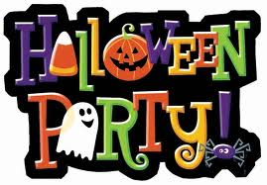
the Halloween party is not till next week.

