Dear Students, Parents and Guardians,

So we meet again! Your child has signed up for a Photo Independent Study, and I just thought I would explain a little bit how that works exactly.

No matter which level they are at, independent study one or two, they have a project due every Friday.

Independent Study One has a handout with all their projects for each week. They pretty much work independently in the darkroom with some assistance from me and the aides. Independent Study Two must come up with ideas for the direction they wish to take their photographic process for each week.

Students are responsible for checking in with me at least once a week. They are responsible for creating their own projects for weeks 15-18.

I provide students with 25 sheets of 8x10 and 5x7. Students are responsible for buying more paper when needed in addition to 3 rolls of film and mats for their portfolio.

They are expected to be role models to other students in the darkroom.

Some things that have remained the same since their original Photography class are:

*Students have all their due dates and assignments as of right now until the end of the semester, so they should always be planning ahead.
*They should be spending at least 30 minutes per week taking pictures.
*Students may always do extra credit assignments for extra credit; this would be turning in extra final prints and taking extra rolls of film.
*In addition to this, I occasionally assign extra credit assignments to visit galleries and museums with their families.
*I keep a lot of the files they need on the Riverside Website.
*Students will be required to create a portfolio, matted, of their best images as their exam grade. Students are also required to make a digital portfolio to upload to the server.

If you have any questions feel free to contact me at any point.
Jessica.presutti@riversideschools.net

Thank you,

Jessica Presutti Biller
Art / Photography Teacher
Art / Music Department Chair

PRESUTTI INDEPENDENT STUDY
PRESUTTI INDEPENDENT STUDY

- You will have a project due every week. This project is to be completed on 8x10 paper unless it is a project that requires more than one piece of paper. You need to put your name, date, and project on the upper left hand corner on the BACK of all your prints in addition to taping a rubric to the back filled out in pencil with the grade you believe you deserve. This is to be put in the inbox unless it is too big.

- You are responsible for asking me for help, this is an independent study which means you are mostly working on your own. If you need help you NEED TO ASK.

- You are responsible for remembering everything from photo 1 and being a leader in the darkroom.

Supplies:

25 sheets of 8x10 and 25 sheets of 5x7.

You will need to buy film and mats.

You will probably need more, the best deal is to go in with someone else and buy a box of 100 and split it. Please research prices before you commit to the class.

You will not be given journal assignments but you will have digital assignments to work on when you’re not in the darkroom.

Exam

You need to make a digital portfolio (take pictures of or scan) ALL of your images and make a powerpoint with each project labeled with week number and description. Make sure all your images are high quality and not blurry.
You need to mat or mount 10 of your best pictures for your portfolio.
Please do not act surprised at the end of the semester when I ask for this, there is rubric at the end of the packet.

Printing Projects

The following is a list of ideas for “recreating” new meaning from your old negatives. You are to complete a different problem every week. Students are responsible for meeting with me every Monday to discuss the problem you are working with. You may use any negative of yours or combination of negatives from the “found” basket. You may also use new negatives. Challenge yourself to be creative with some negatives you may have thought were useless. All printing problems should reflect an extension beyond Photo I assignments.
You must show proof you have taken 3 new rolls of film!!!!
All projects are due the Friday of this week, you must turn in at least 1 final print for each assignment! You may play as much as you want but I must receive a good final print every Friday with a rubric attached.
All final prints must be on 8x10 paper
I still do not accept any late work! Scan your work as you go, you will need to turn in a digital portfolio as well as a formal portfolio.

Week 1
- Take your worst negative. Print it 3 times at three different exposures. (size can vary) Cut or tear the prints and collage together to create a new image. (you can use 5x7 paper for this)
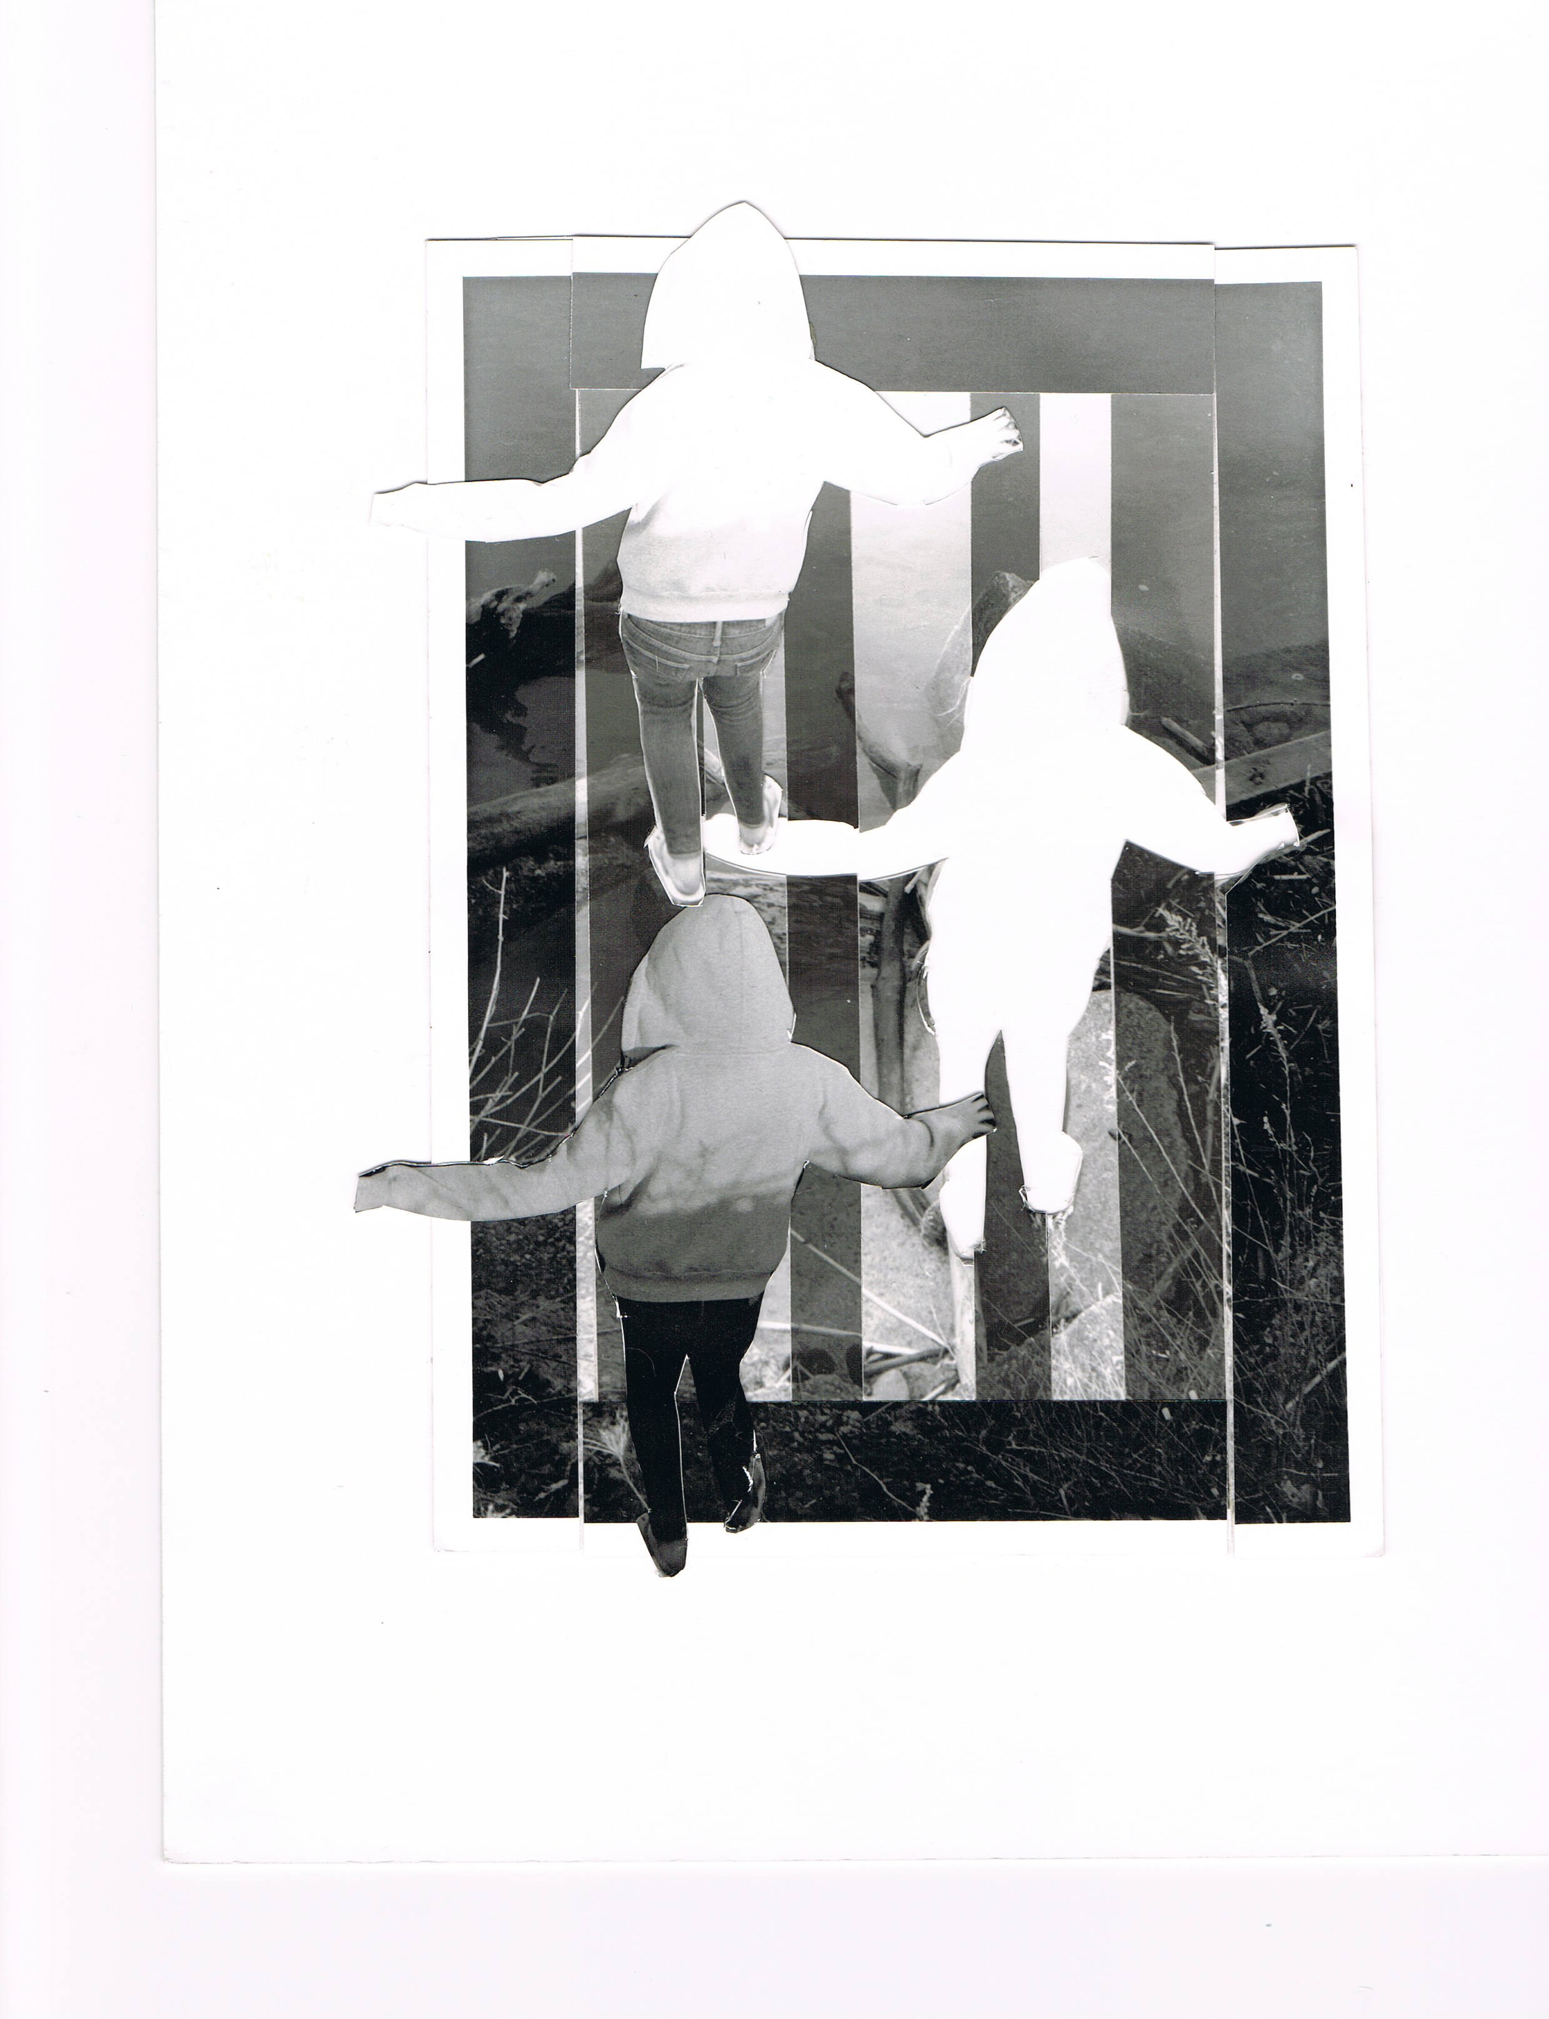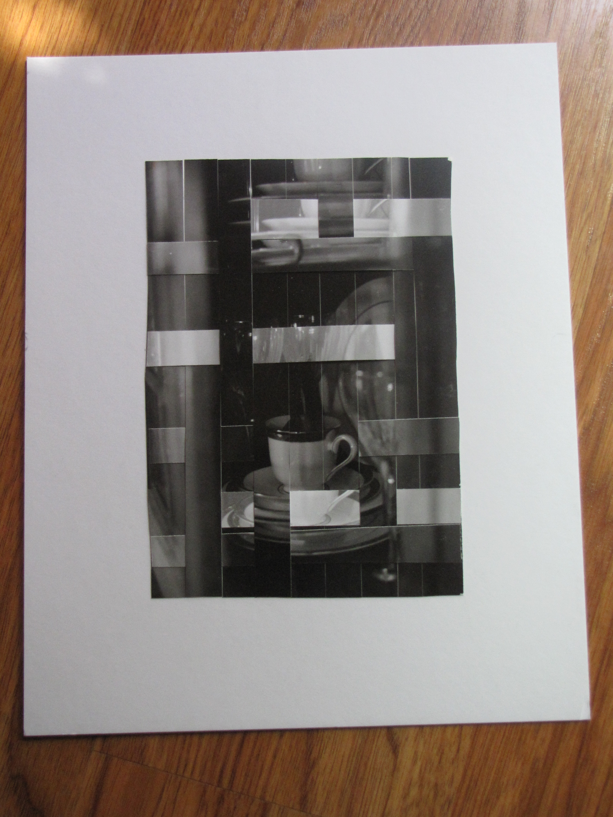
Week 2

- Intentionally dodge or burn an area of a print to give a new meaning to the image. This is not burning or dodging for proper density, but for giving a different emphasis.

Week 3 (take and develop a roll of film this week and turn in with your print!)

- Create an interesting photogram that includes an exposure of one of your negatives as well as objects on top.
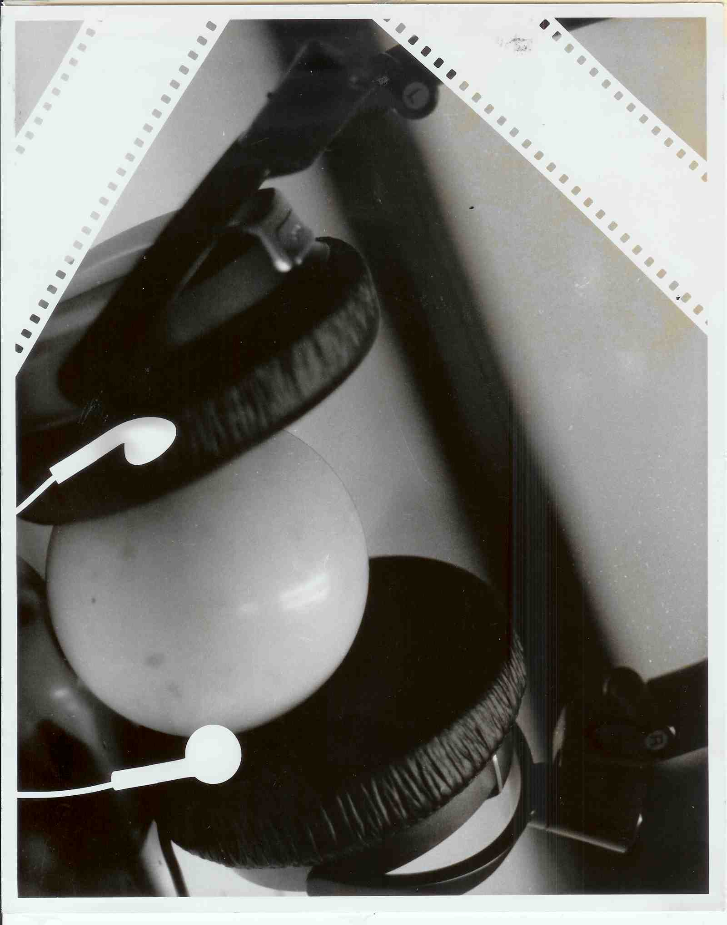

Week 4

- Place a piece of wet tissue paper on your paper and expose an image

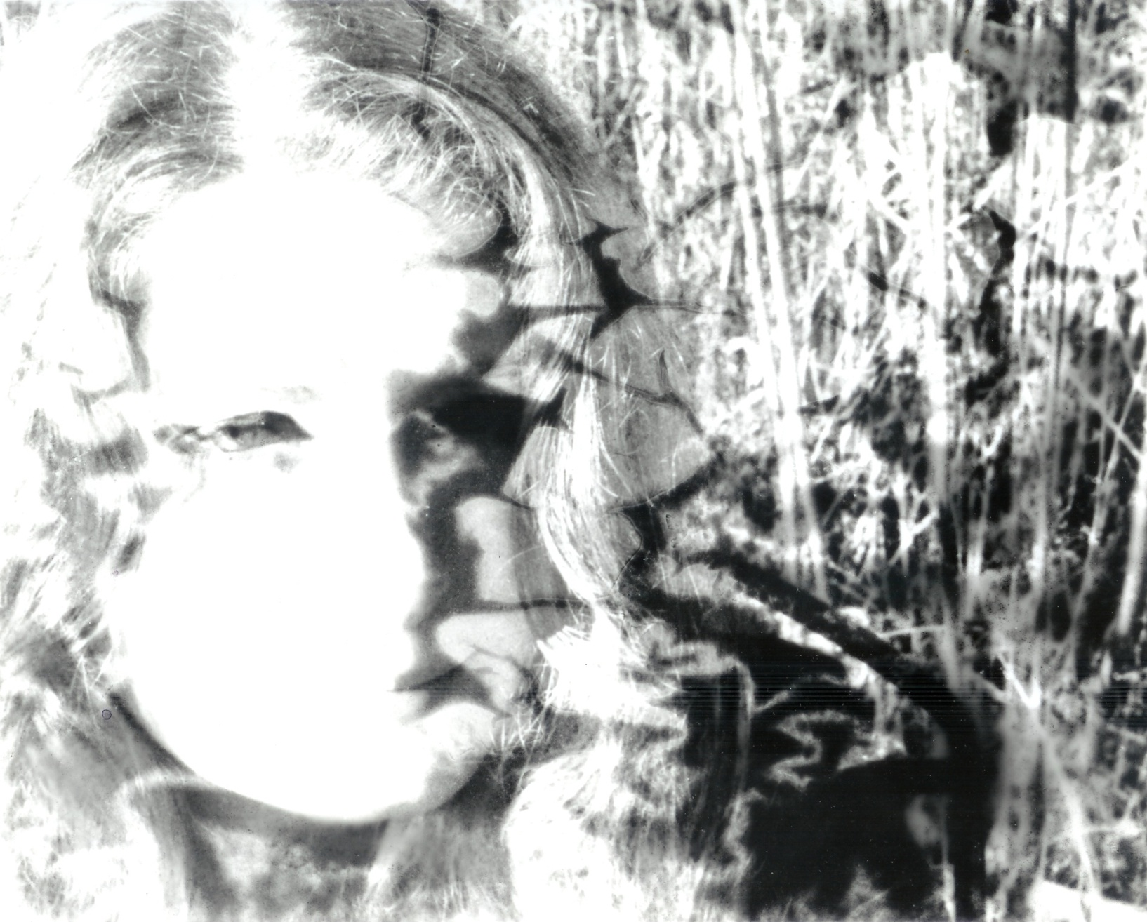

Week 5
- Use text with an image, you can write on plexy glass or plastic, you can create a stencil, you can print out lettering on plastic, but it must 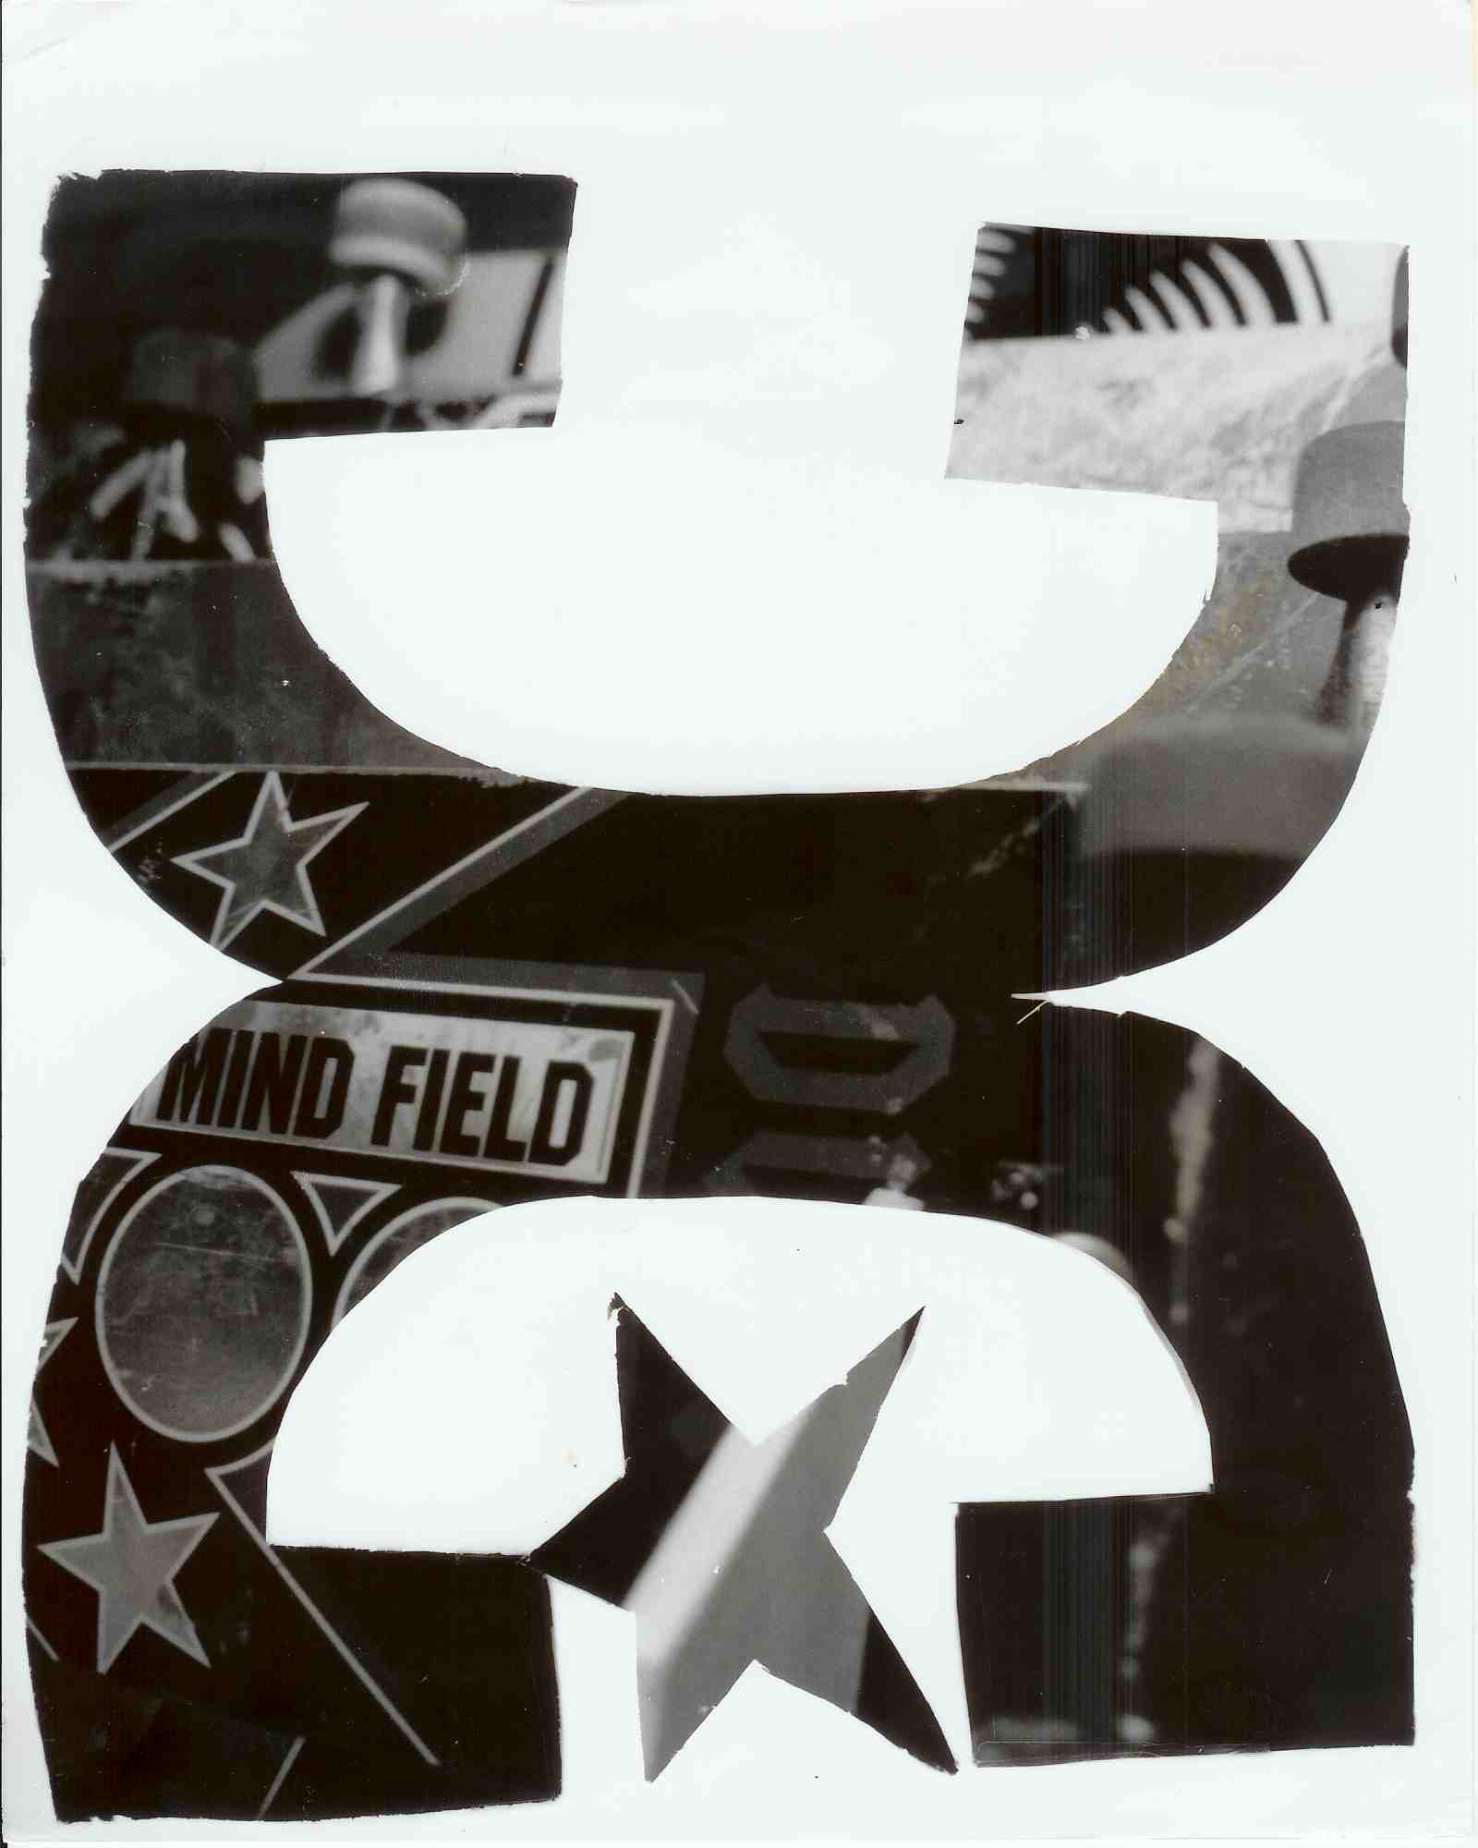be properly laid out because the edge of the plastic will make a line wherever it hits your paper.

Week 6 (take and develop a roll of film this week and turn in with your print!)

- Kool aid dye a print, choose your image wisely! HIGH CONTRAST!

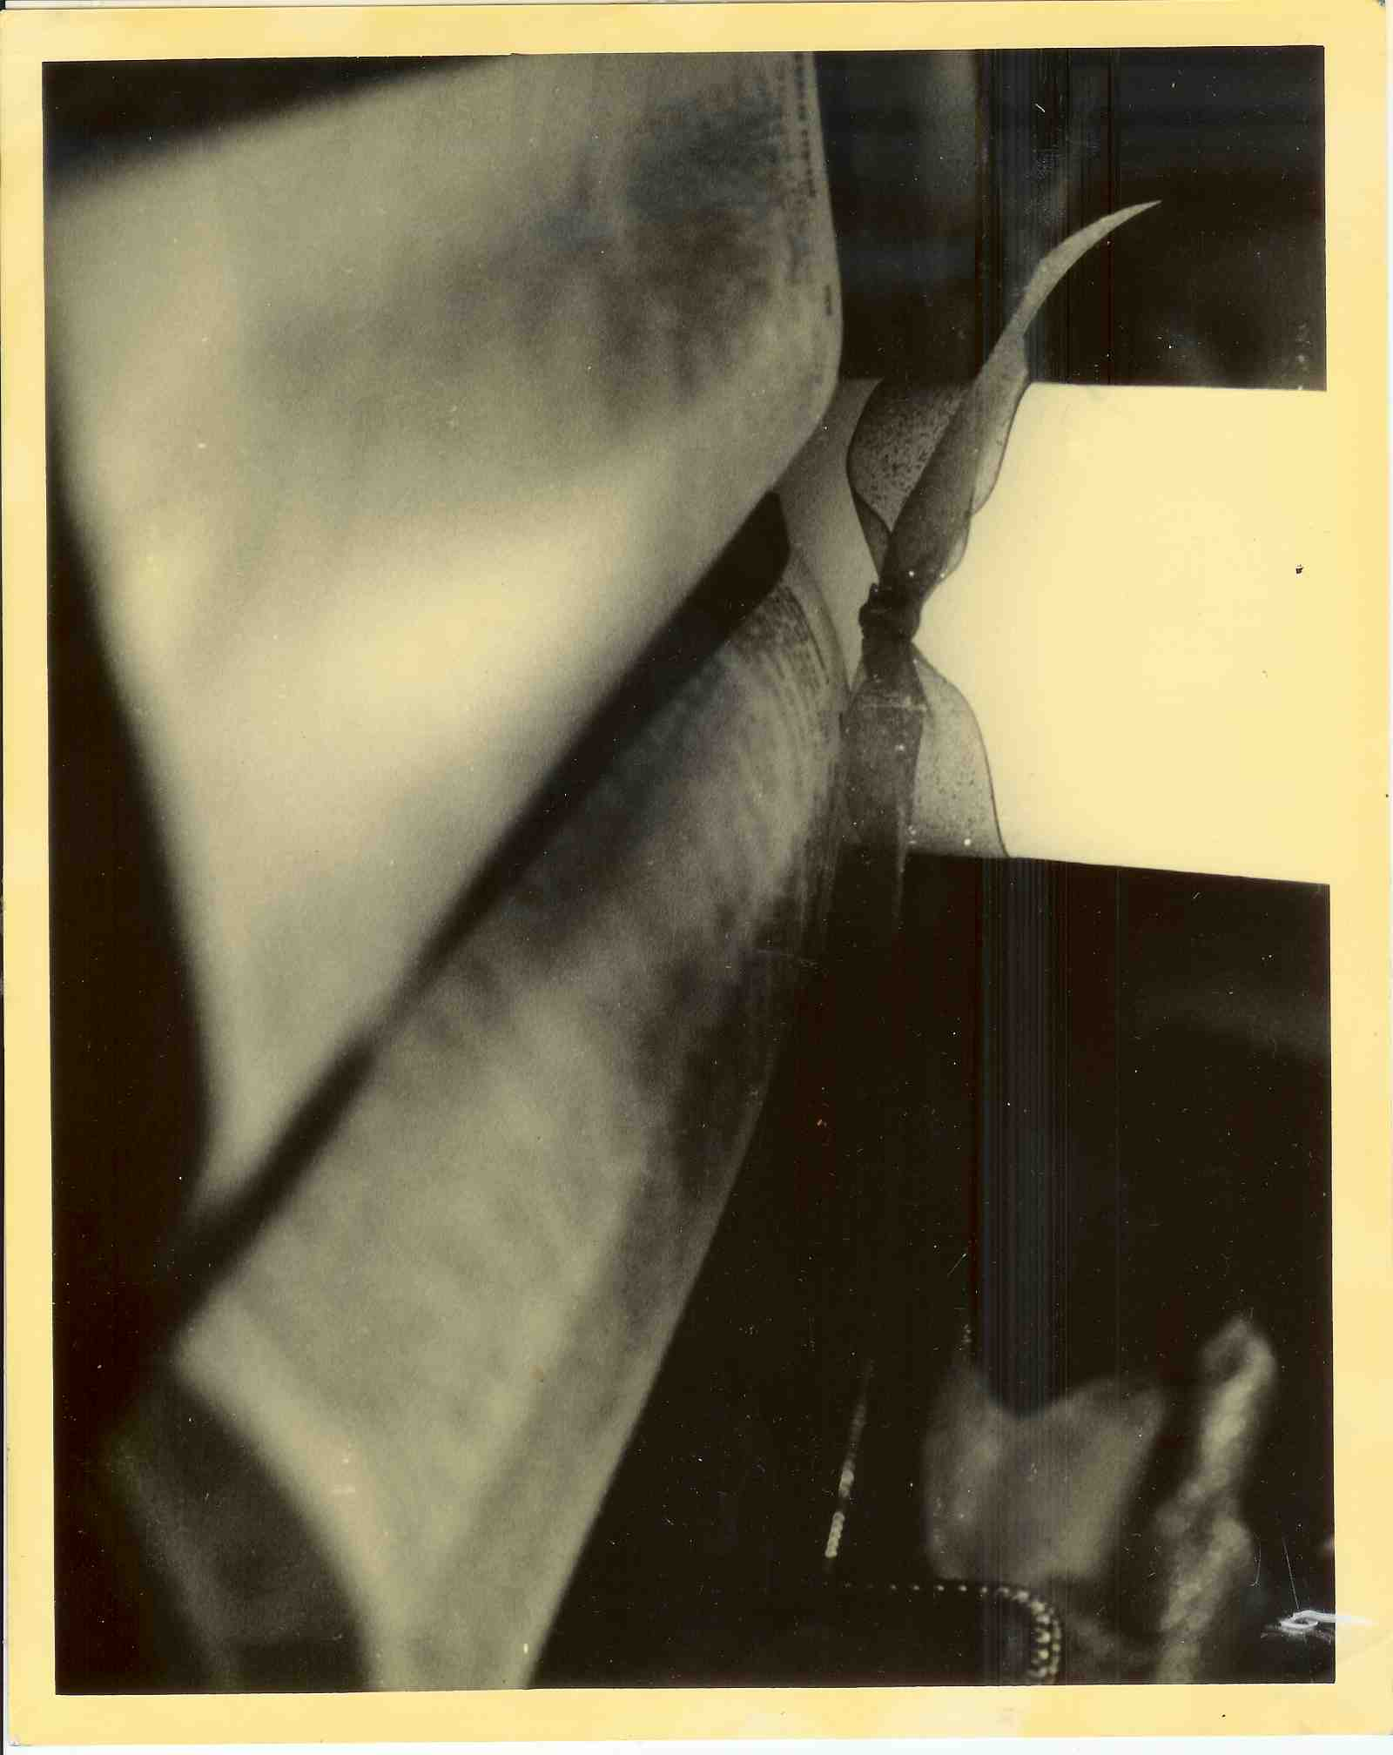

- Week 7
- Use 5x7 paper. Enlarge a negative as big as possible. Crop and specifically select 4 areas to print. (the areas selected may not incorporate the whole image, look for leading lines or similar shapes) Mount as a grid ON MAT BOARD

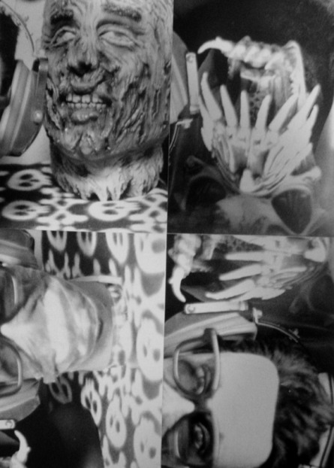

Week 8
Make a paper weavewith two completely different images, one being of a person. 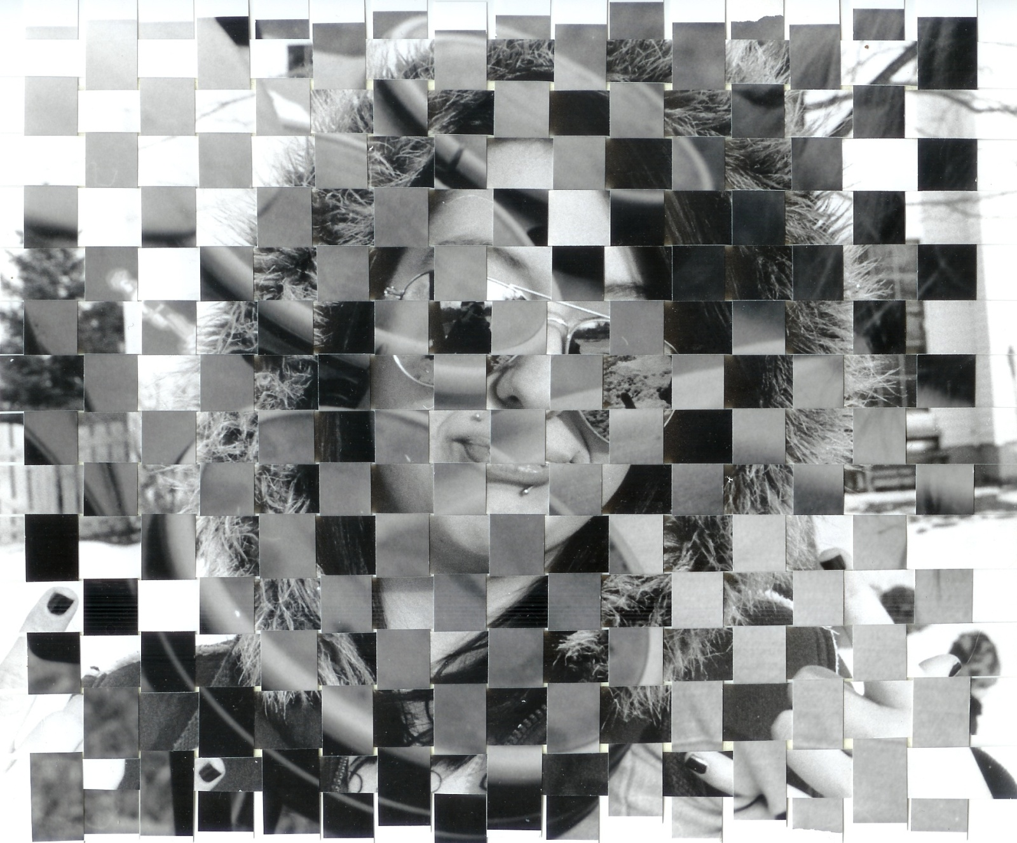

Week 9

- Scratch, bend, heat a negative for experimental effect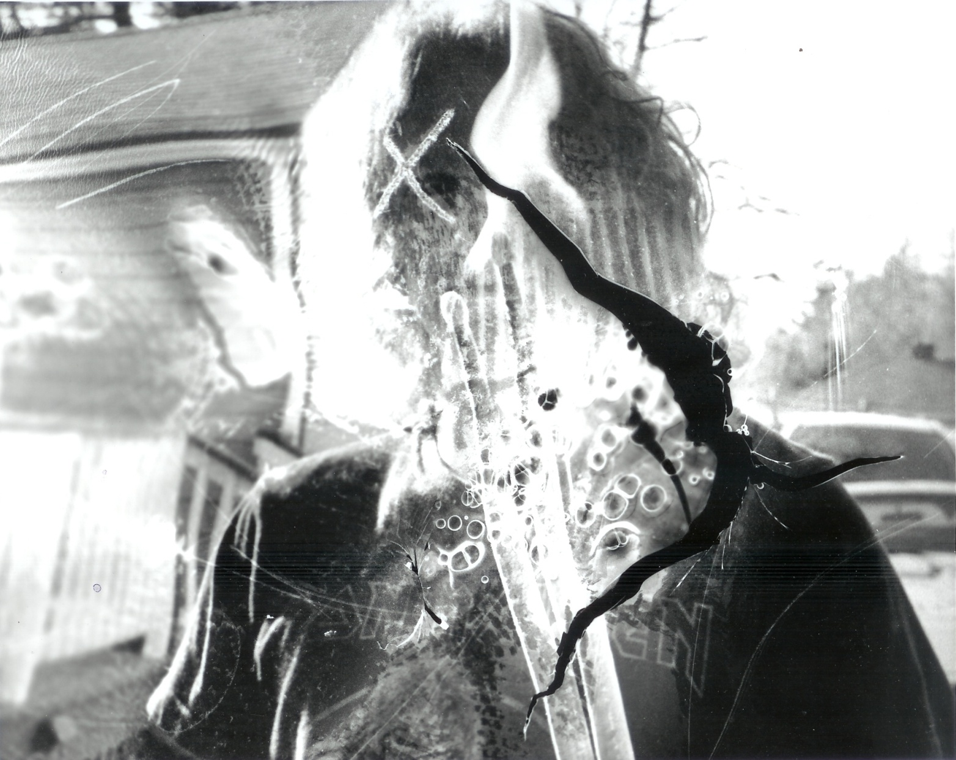

Week 10

- Apply developer with a object….paper towel, cotton ball, paint brush (be creative but don’t ruin the developer by leaving chunks of what you’re using!
- 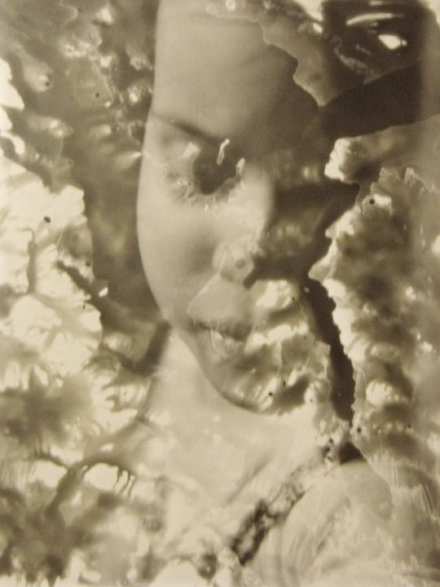

Week 11 (take, develop and turn in roll of film)
- Add art materials to a print, oil pastels, watercolor etc…must use a very high contrast print! Use filters to achieve this affect.

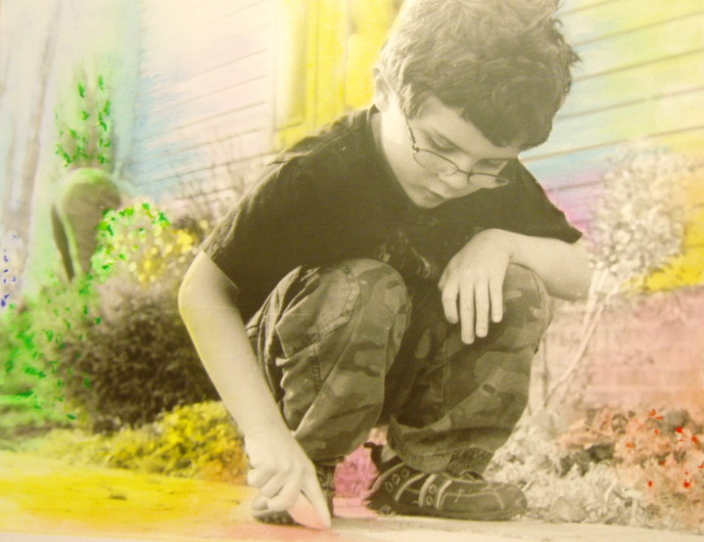

Week 12
Make a print using 2 negatives, whether you do a double exposure or expose one at a time.
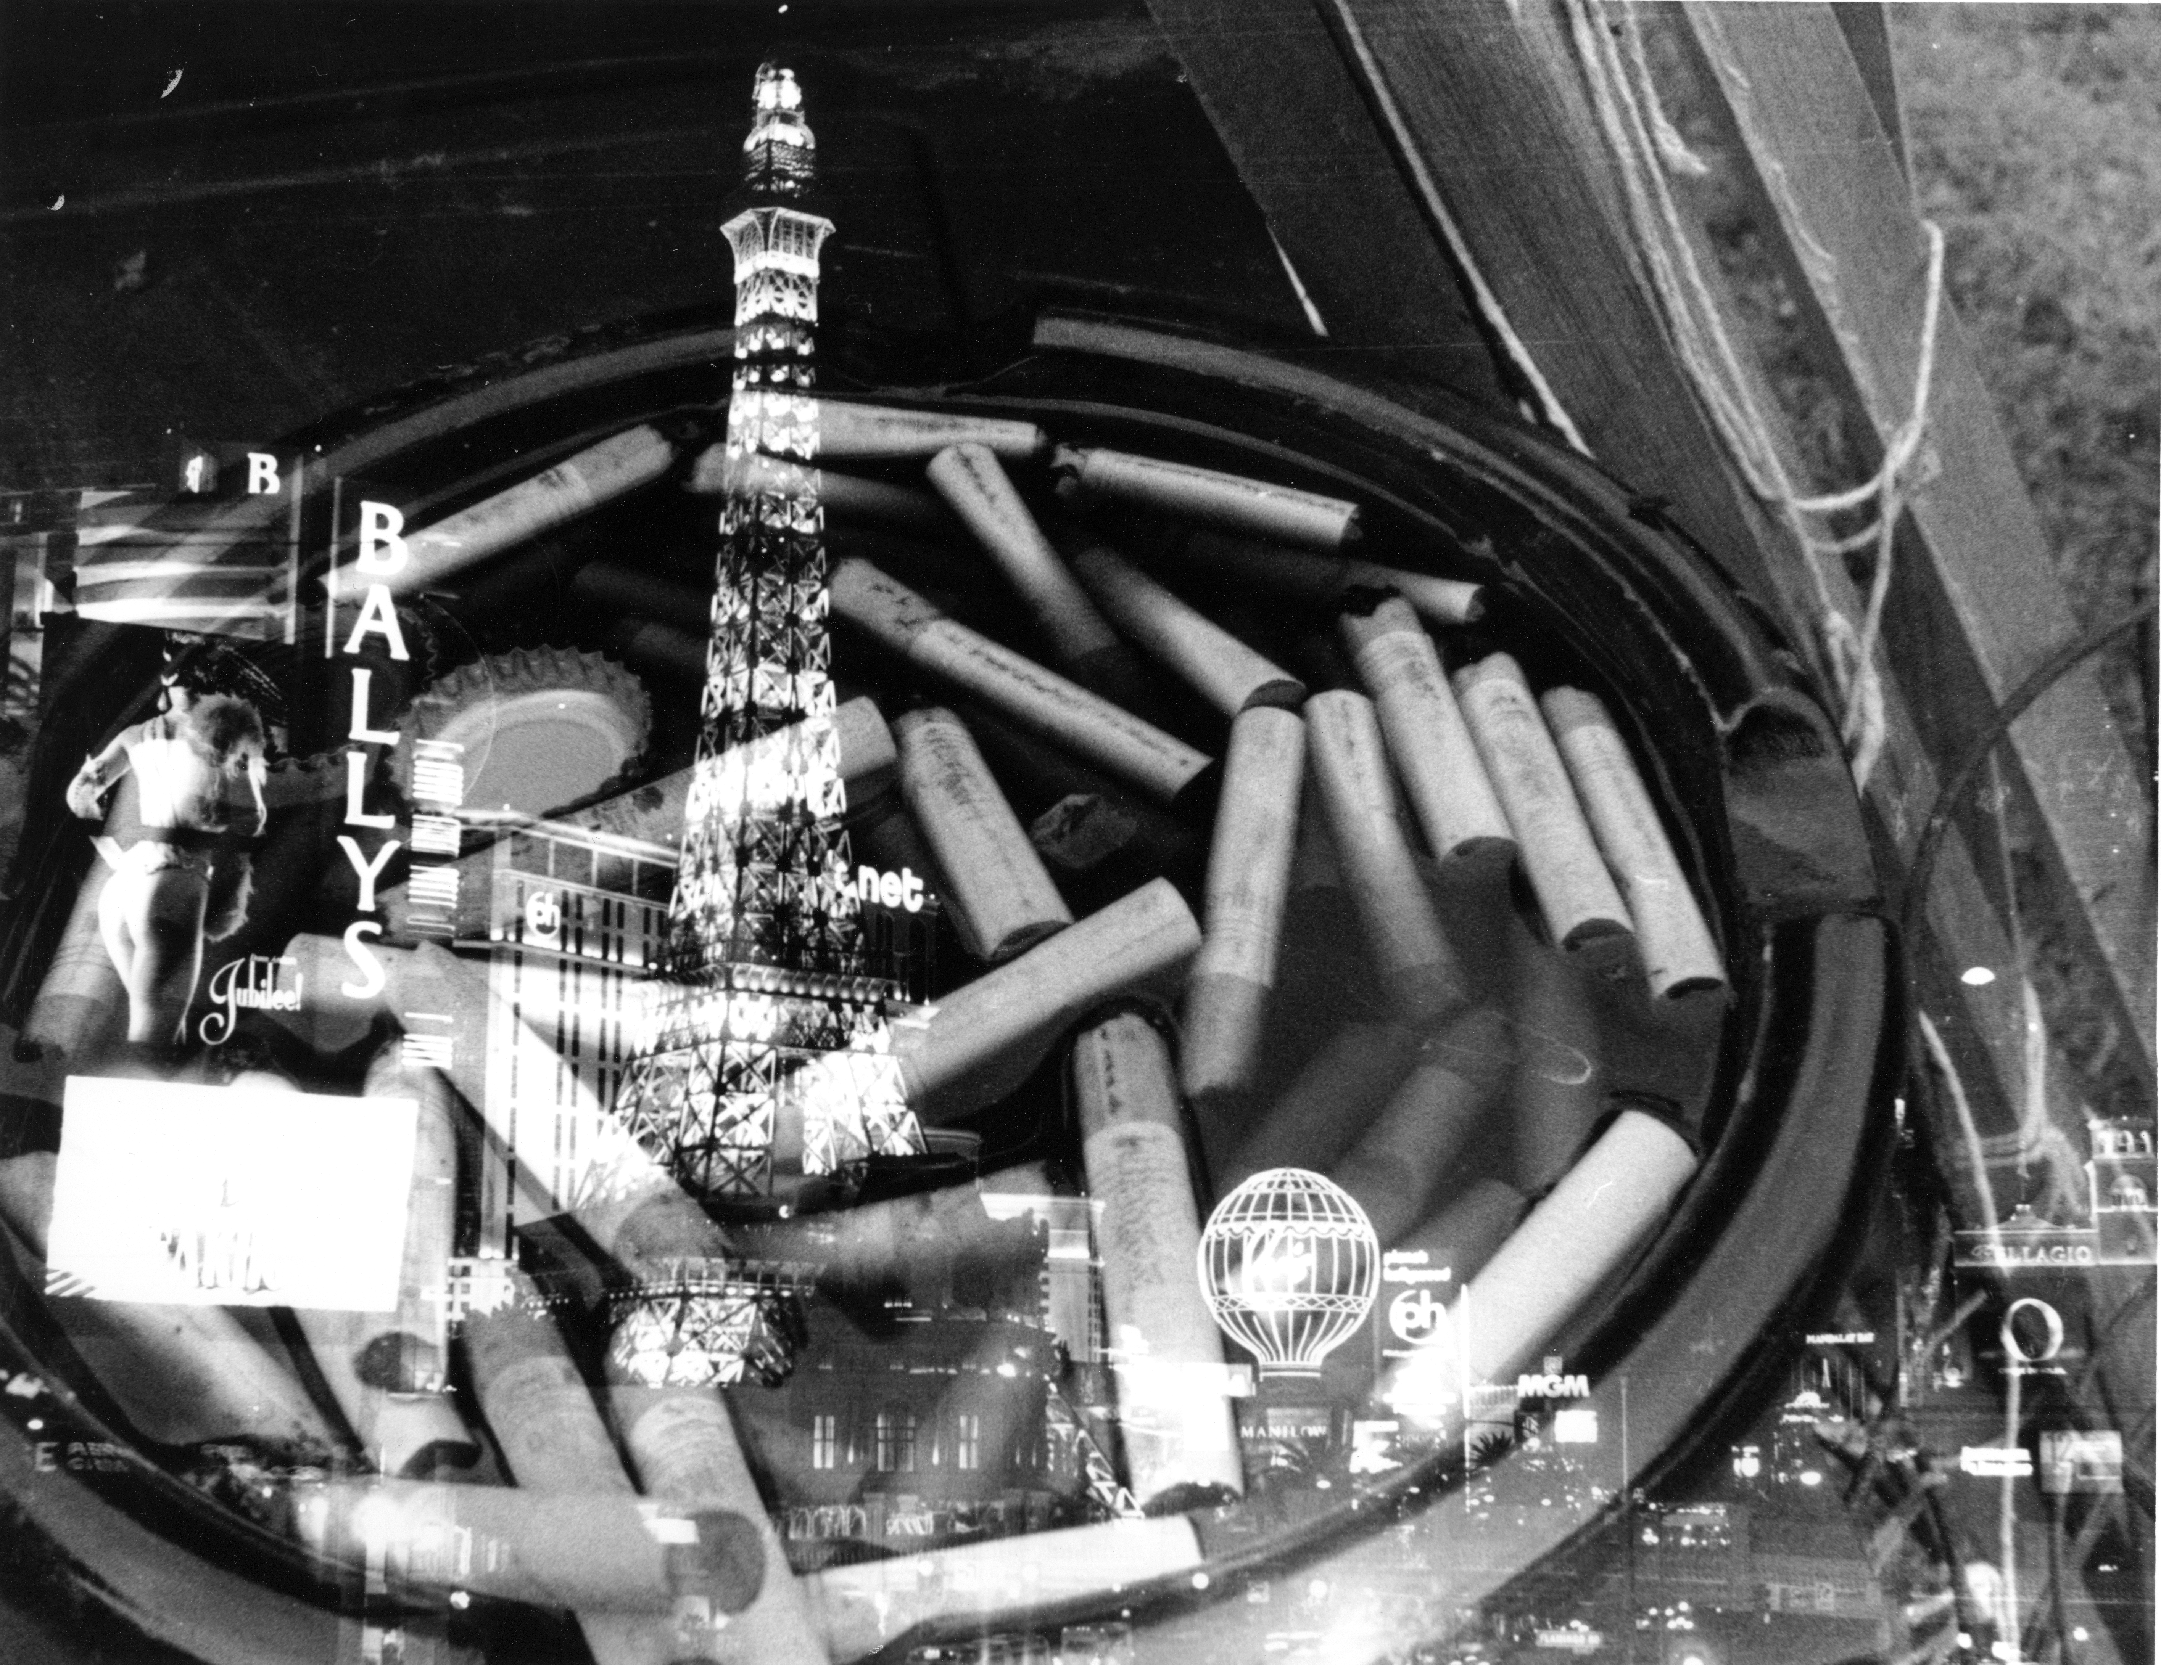

Week 13
Experiment with solarization techniques, research solarization, turn in written research in addition to prints. Research for weeks14-18 due!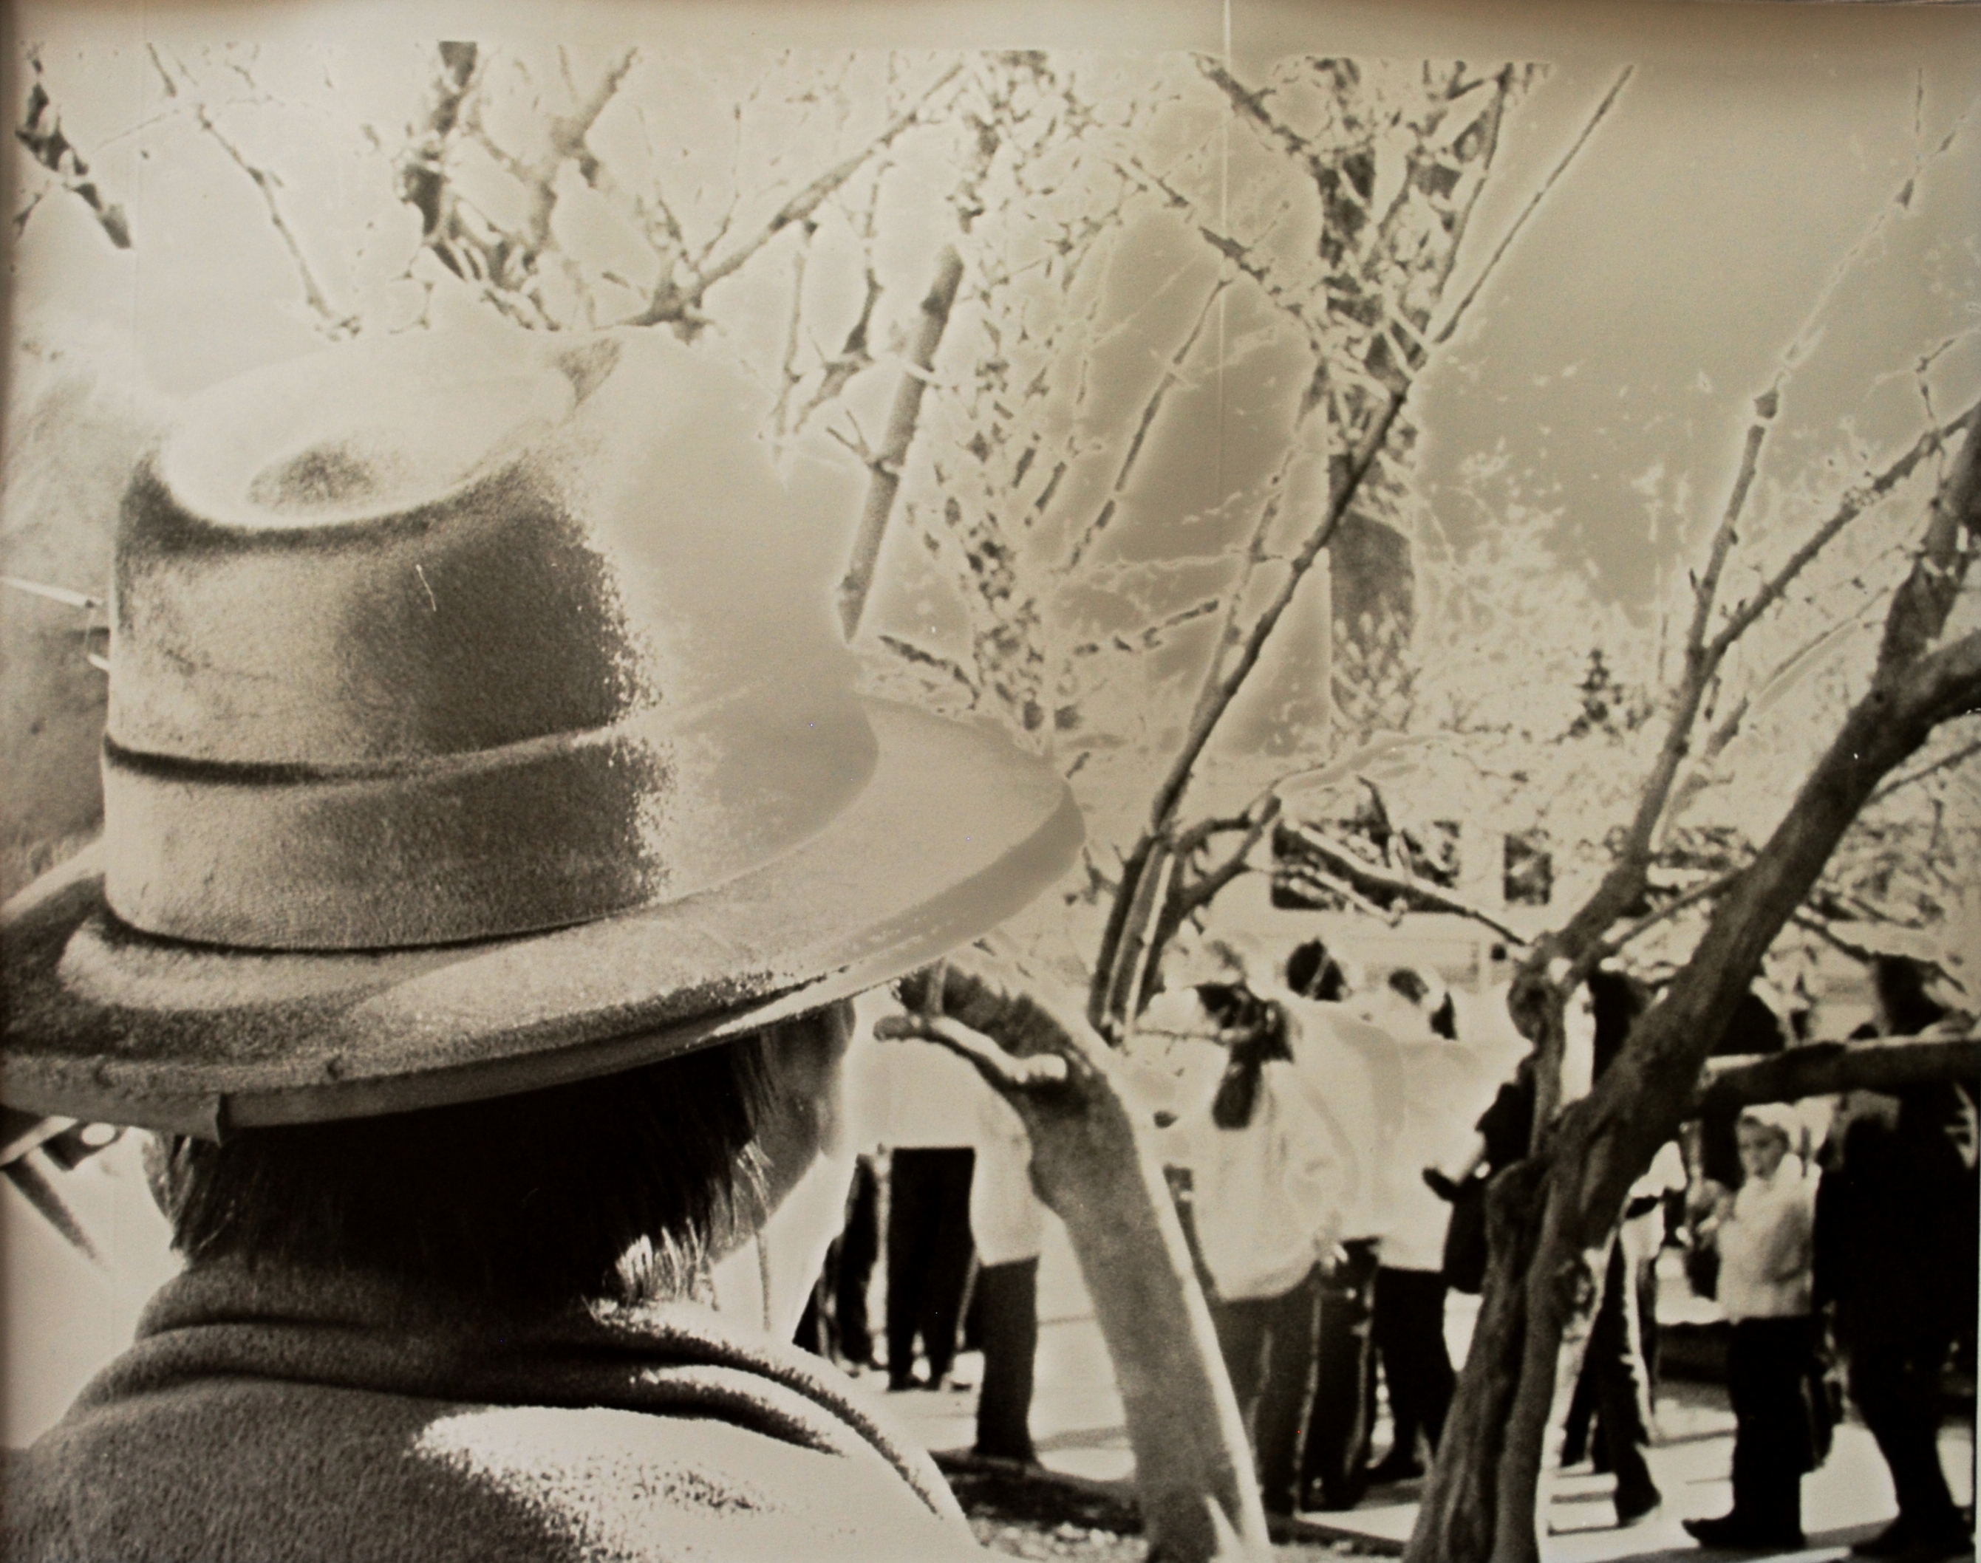

Week 14-18

Research:

Use the photo books and magazines provided here in class to look for ideas to add to the list.

The Internet is a tremendous resource for ideas, techniques and photographers experimenting with the medium. Begin a search with:

http://photography.about.com/cs/photomontage/
you must use one of your weeks to do a photomontage
.

Look through the list of sub topics on the left side of the photography.about .com page. You will soon be lead many sources. Under techniques you will find good instructions for Solarizations. Don't forget to check the Pinhole pages, making a pinhole camera would be a great final project!

Or do a search at www.vivisimo.com. Type in photography+techniques. Vivisimo does a nice job of categorizing the findings so you don't have to search through title after title.

Be prepared to report to the class on some techniques you discover.

The last 4 weeks should be your busiest, for you will be responsible for creating an awesome portfolio for your final exam in addition to finishing your last 4 prints. You should have at least 18 8x10 prints by the end of the semester!
10 of those prints needed to be presented in a professional manner, and be “ready to hang on the wall condition” All 18 prints need to be scanned and or photographed and uploaded to the server (make a powerpoint and label each project with project number and description)

Name___________________________________________________________

For each week you need to describe in detail what you will be doing, remember the only required project is a photomontage mounted on foamcore.
This must be turned into me during the 13th week.

Week 14 Explain what you are doing for your photomontage, your objective and subject please. ____________________________________________________________________________________________________________________________________________________________________________________________________________________________________________________________________________________________________________________________________________________________________________________________________________________________________

Week 15
____________________________________________________________________________________________________________________________________________________________________________________________________________________________________________________________________________________________________________________________________________________________________________________________________________________________________

Week 16
____________________________________________________________________________________________________________________________________________________________________________________________________________________________________________________________________________________________________________________________________________________________________________________________________________________________________

Week 17
____________________________________________________________________________________________________________________________________________________________________________________________________________________________________________________________________________________________________________________________________________________________________________________________________________________________________

Week 18

____________________________________________________________________________________________________________________________________________________________________________________________________________________________________________________________________________________________________________________________________________________________________________________________________________________________________

PRESUTTI INDEPENDENT STUDY

SHOOTING ASSIGNMENT
Break Some Old Habits

When you see a situation you want to photograph you should ask yourself some basic questions-
What is the theme or subject? What is the subject matter?
How does the subject matter express the subject?

Objectives: To improve your visual thinking
To observe more accurately
To develop your imagination
To express a theme or subject more effectively

In taking an independent study with me you must take at least 3 new rolls of film, you will show me the negatives as you finish them. These are just some suggestions, though I do expect something completely different from the images you took in Photo I. The goal of photo II is for you to experiment while you have an available darkroom, you can always take pictures outside of this class.
Every time you find you’ve learned something new I need a written document of this, so when completing experiments make sure you keep track of exactly what you are doing, this way we can redo it if it comes out successful. This document will be turned in with your final image.
In addition to your weekly assignments you must complete 3 rolls of film, for you will need this film to complete the weekly assignments.
Below you will find ideas for new rolls of film, you must pick at least one of the suggested assignments.
Lastly you are required to do a photomontage. When you are ready for this project we will meet and discuss the criteria and process.

Taking Risks
Whether you feel you have talent or not, you can learn to do an enormous number of different things with the camera. Look and observe everywhere, and you will see photographic possibilities. The rewards go to those who just don’t sit there, but to those who take chances.
It takes motivation and courage to experiment in new places, with new subjects, or with new styles. You are certain to make some mistakes and perhaps feel a sense of failure. Don’t let disappointment deter you. By trying unfamiliar pictorial approaches, even when they don’t turn out right, you learn.
Observe
Focused observation should be every photographer’s goal. Examine things in detail and believe they are important in their own right. Build a mass of visual information about your subject matter by observing it from many points of view.
Abandon your normal premises and go on a search for new ones.
Consider approaches and techniques you have never tried before; search for new beginnings.
Option 1: Break a Few Rules
Try a few techniques. Don’t waste a whole roll of film on one thing in this list. Some are silly and purely accidental.
- Jump up and down in a place where there is a good variation in contrast of values. Press the shutter release as you jump.
- Run toward a still object and press the shutter release as you run.
- Make sure the strap on your camera is absolutely secure. Set the shutter at a slow speed, and activate the self-timer. Swing your camera in circles, or back and forth, until the shutter has released.
- Shoot some pictures in which the main subject is clearly out of focus, but other things are sharp. Shoot a sunset, a flower, or the surface of backlighted water entirely out of focus.
- Overexpose or underexpose on purpose
- Take some pictures in which the foreground fills the lower 2/3 of the frame. See what interesting effects you can get by intentionally “weighting” a photo very strongly toward the top. Or do the opposite, where the weight is at the bottom.
- Explore how objects, people, and the earth interact with rain. What mood does rain provoke? How does it change the way people and things look and act? (Be sure to protect your camera)
- Shoot some photos with a very limited range of values – black on black, white on white, gray on gray
- If you have a zoom lens, deliberately zoom in and out while taking a shot. (the shutter speed needs to be a half second or longer, work indoors or in low light)
- Tilt the camera up and down while using a slow shutter speed.
- Play with deliberate blur; slow shutter speeds; panning
Option 2: Familiar Things
- Lock yourself in your bathroom. Give yourself twenty minutes to take ten pictures.
- As soon as you get up in the morning, take some shots from the prone position
- Photograph one object from several different angles
- Photograph store windows. Look for merchandise on display and reflections in the glass. Try to catch something unusual or even humorous. Look for patterns and combinations of objects.
- Photograph interesting feet or expressive hands.
- Choose some objects and possessions of personal value. Arrange them in a still life and shoot from many angles
- Everything has a unique shape, color, texture, and function. Observe utilitarian objects and present their quality as well as function. Look at sewer covers, lampposts, gates, doorknockers, logos for businesses, advertising posters, billboards, even graffiti. Put them with in their context or in a usual setting.
Option 3: Imagining
- Look for visual similarities between subjects and subject matter. Select a subject such as “delicacy.” Then ask, “what subject matter expresses my subject and why?”
- Practice foresight. Before you actually photograph something, make the photo in your mind. Work out in advance solutions to problems you may encounter.
- Pay attention to your dreams. You may visualize something in a dream that you can work out in a photograph.
- Make a shadow appear in sharper focus than the surrounding “realities.”
- Indulge in fantasy. Ask yourself “what if” then try to photograph the results. What technique could you use to visualize the following _ “what if a dog had wheels instead of legs?”
- Shoot a recollection or past sensation. Go to a location that elicits particular feeling you experienced as a child. Don’t photograph for the literal detail, but look for the emotional response. What affected you about the place?
- Contrive a situation to elicit questions from the viewer. Can a title make a photo more interesting?
- Photograph a place when you are in a good mood. Then re-photograph when you are in a bad mood.
- Try deliberate double exposures (Consult your manual to find out how to do it with your camera.)
- Photograph opposites -- good /bad, hot/cold, soft/hard, etc.
- Try to photograph a smell
- Make music with your eyes
- Take some photos that illustrate a poem or the lyrics to your favorite music.

Option 4:

- Photograph FOOD -- think You Are What you Eat
How can you present images of food that express our obsession with food?

Option 5:
- Theme for the semester----
BOUNDARIES -- BARRIERS -- FENCES

Do not be literal; find examples of how we are constrained. What keeps us from doing what we want to do? What barriers do you feel?

You must be open and willing to explore various strategies. Follow your instincts. By exploring your deepest feelings, sensitivities, and fears, you will invariably show viewers the world as only you see it. Daydreaming offers an endless source of one of a kind pictures – anywhere you look offers a choice. Let your response to the subject be immediate. Stop thinking and become absorbed in your more impulsive side

Photocubism
The Photocollages of David Hockney
Intrigued by how Cubist painters incorporated multiple viewpoints of a single subject, British artist David Hockney applied it to the medium of photography. You will be creating a photocollage based on Hockney’s work.
Supplies needed:
3 rolls of 36 exposure film. Any brand film. You can use either 100 or 400 ASA film, black and white or color, but make sure you camera’s ASA dial is correctly set if it is not done automatically. You may also use digital.
- Compose a photo with a strong center of interest. Since you are taking pictures of a very wide area, you should keep your center of interest very close.
- If your camera has a Program mode (P) you may use it for this assignment. If you’re using a semi-automatic or manual camera remember to use your meter to get the correct exposure on every shot. You must also make sure your camera is correctly focused for each shot.
- Remember, never to move from your spot until you’re done. You may tilt the camera up and down during the shoot, but never change your shooting position.
- Practice shooting first. The idea behind Hockney’s approach is to photograph a large scene by breaking it up into many smaller ones. You must think of your scene as having an invisible grid with overlapping squares placed upon it. Begin shooting with only your waist turned three-quarters to the left. Continue to shoot your first horizontal row of photos, remembering to always overlap the photo you just took, until you reach a position where your waist is turned three-quarters to the right. Every once and awhile zoom in and out.
- Begin to shoot the second row of horizontal photos as you did previously, but you must also overlap the top of this row with the bottom of the last row.
- Continue to shoot the entire scene always overlapping both vertically and horizontally until you complete the scene.
- Shoot the real thing when you feel comfortable. Bring the film in for processing. Ask for matte finish and an extra set of prints.
- Mount the images to foam core board using rubber cement or image safe spray glue.

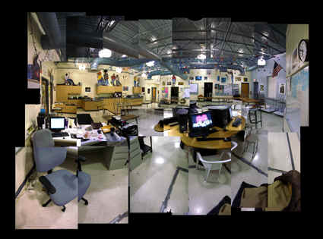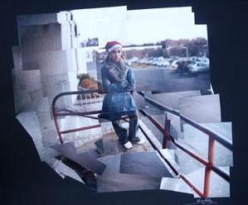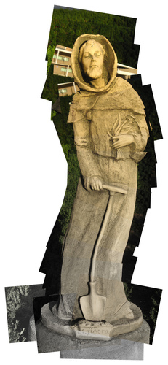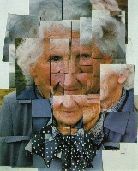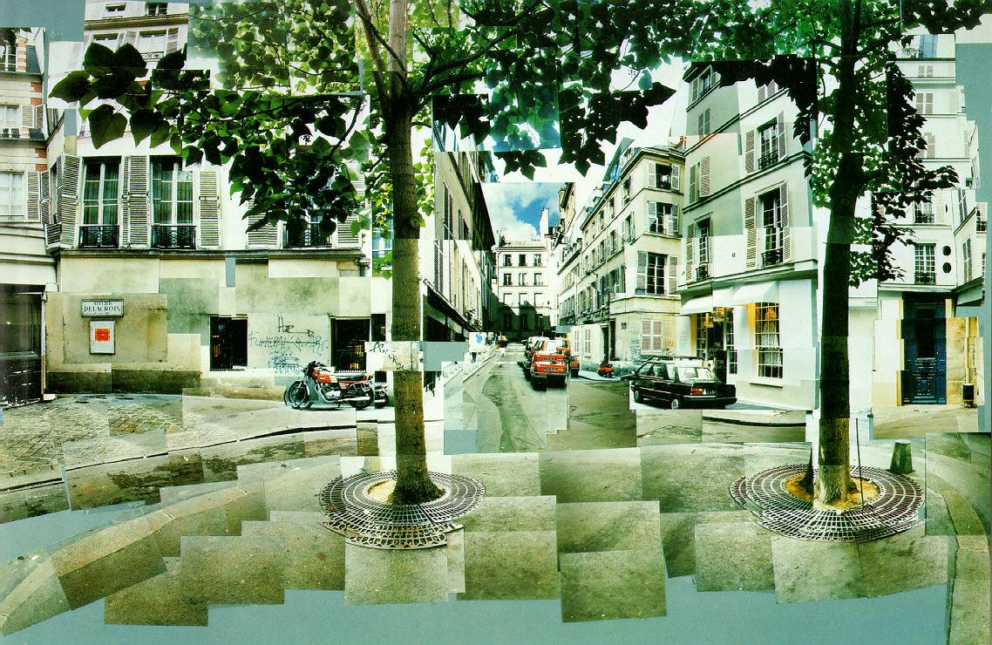

Name Project Name Week #
Self  grade | Teacher  Grade |  | 5 | 4 | 3 | 2 | 1
 |  | Value/Contrast | Image(s) have an excellent range in value. It is obvious there black, white and all the values in between. |  | The value and contrast are satisfactory, but there could be some improvement made with the use of filters. |  | Image is quite gray with a lack of black, white and the values in-between.
 |  | Composition | The student made great use of negative space. The viewer’s eye moves easily throughout the composition and the composition is well balanced. Depth of field is carefully manipulated. |  | The student made some use of negative space. The viewers eye moves throughout the composition with some hesitation and the composition is somewhat balanced. There is some evidence that depth of field was considered. |  | The negative space is not used well. The viewer’s eye does not move easily throughout the composition and the composition is not well balanced. Depth of field was not manipulated or considered.
 |  | Communicative Properties/Content | Shows obvious evidence of thinking, it may address fairly complex visual or conceptual ideas, the image is presented in an effective way to communicate. Shows a sense of inventiveness or imagination, a sense of style or engagement with experimentation. |  | Work shows a real sense of effort, but problems are not successfully resolved. The image fulfills the assignment given and shows intent. The level of work may be inconsistent, but the work is strong enough to offset it’s weaknesses |  | There is little, if any, evidence of thinking and there are major problems that need to be worked out. The image does not fulfill the assignment given.
 |  | Technique | It is evident the student had a great understanding of the materials and their use. Print is of excellent quality. |  | It is evident the student had some understanding of the photographic materials and their use. The materials generally well handled, but there are some technical issues such as: dust, scratches, exposure, needed dodging or burning. |  | It is evident the student had difficulty understanding the photographic materials and their proper use. There are many issues technically, with dust, scratches, exposure and needed burning or dodging.
 |  | Craftsmanship | The actual quality of the print is in excellent quality. Mounting is well done. Everything is neat and clean |  | The condition of the print is less than desired, with bent edges, visible adhesive, pencil lines or dirt being apparent on the image. |  | The image is in poor condition, the mounting is done carelessly with many of the following problems: adhesive showing, pencil lines showing, dirt, dust bent or folded areas.
 |  | Growth | Student’s skill improved throughout the project duration. Student took what they learned in previous photography class(es) and improved upon their skills. |  | Student’s skill improved throughout the project duration. Student took what they learned in previous photography class(es) and improved somewhat upon their skills. |  | There was no growth made on the project. Student did not show previous knowledge of the material. If the student took steps backwards they will receive a score of 0.
 | Using the effort rubric on the wall, use it to give yourself an effort score 1-4

Name Project Name Week #
Self  grade | Teacher  Grade |  | 5 | 4 | 3 | 2 | 1
 |  | Value/Contrast | Image(s) have an excellent range in value. It is obvious there black, white and all the values in between. |  | The value and contrast are satisfactory, but there could be some improvement made with the use of filters. |  | Image is quite gray with a lack of black, white and the values in-between.
 |  | Composition | The student made great use of negative space. The viewer’s eye moves easily throughout the composition and the composition is well balanced. Depth of field is carefully manipulated. |  | The student made some use of negative space. The viewers eye moves throughout the composition with some hesitation and the composition is somewhat balanced. There is some evidence that depth of field was considered. |  | The negative space is not used well. The viewer’s eye does not move easily throughout the composition and the composition is not well balanced. Depth of field was not manipulated or considered.
 |  | Communicative Properties/Content | Shows obvious evidence of thinking, it may address fairly complex visual or conceptual ideas, the image is presented in an effective way to communicate. Shows a sense of inventiveness or imagination, a sense of style or engagement with experimentation. |  | Work shows a real sense of effort, but problems are not successfully resolved. The image fulfills the assignment given and shows intent. The level of work may be inconsistent, but the work is strong enough to offset it’s weaknesses |  | There is little, if any, evidence of thinking and there are major problems that need to be worked out. The image does not fulfill the assignment given.
 |  | Technique | It is evident the student had a great understanding of the materials and their use. Print is of excellent quality. |  | It is evident the student had some understanding of the photographic materials and their use. The materials generally well handled, but there are some technical issues such as: dust, scratches, exposure, needed dodging or burning. |  | It is evident the student had difficulty understanding the photographic materials and their proper use. There are many issues technically, with dust, scratches, exposure and needed burning or dodging.
 |  | Craftsmanship | The actual quality of the print is in excellent quality. Mounting is well done. Everything is neat and clean |  | The condition of the print is less than desired, with bent edges, visible adhesive, pencil lines or dirt being apparent on the image. |  | The image is in poor condition, the mounting is done carelessly with many of the following problems: adhesive showing, pencil lines showing, dirt, dust bent or folded areas.
 |  | Growth | Student’s skill improved throughout the project duration. Student took what they learned in previous photography class(es) and improved upon their skills. |  | Student’s skill improved throughout the project duration. Student took what they learned in previous photography class(es) and improved somewhat upon their skills. |  | There was no growth made on the project. Student did not show previous knowledge of the material. If the student took steps backwards they will receive a score of 0.
 | Using the effort rubric on the wall, use it to give yourself an effort score 1-4
Name Project Name Week #
Self  grade | Teacher  Grade |  | 5 | 4 | 3 | 2 | 1
 |  | Value/Contrast | Image(s) have an excellent range in value. It is obvious there black, white and all the values in between. |  | The value and contrast are satisfactory, but there could be some improvement made with the use of filters. |  | Image is quite gray with a lack of black, white and the values in-between.
 |  | Composition | The student made great use of negative space. The viewer’s eye moves easily throughout the composition and the composition is well balanced. Depth of field is carefully manipulated. |  | The student made some use of negative space. The viewers eye moves throughout the composition with some hesitation and the composition is somewhat balanced. There is some evidence that depth of field was considered. |  | The negative space is not used well. The viewer’s eye does not move easily throughout the composition and the composition is not well balanced. Depth of field was not manipulated or considered.
 |  | Communicative Properties/Content | Shows obvious evidence of thinking, it may address fairly complex visual or conceptual ideas, the image is presented in an effective way to communicate. Shows a sense of inventiveness or imagination, a sense of style or engagement with experimentation. |  | Work shows a real sense of effort, but problems are not successfully resolved. The image fulfills the assignment given and shows intent. The level of work may be inconsistent, but the work is strong enough to offset it’s weaknesses |  | There is little, if any, evidence of thinking and there are major problems that need to be worked out. The image does not fulfill the assignment given.
 |  | Technique | It is evident the student had a great understanding of the materials and their use. Print is of excellent quality. |  | It is evident the student had some understanding of the photographic materials and their use. The materials generally well handled, but there are some technical issues such as: dust, scratches, exposure, needed dodging or burning. |  | It is evident the student had difficulty understanding the photographic materials and their proper use. There are many issues technically, with dust, scratches, exposure and needed burning or dodging.
 |  | Craftsmanship | The actual quality of the print is in excellent quality. Mounting is well done. Everything is neat and clean |  | The condition of the print is less than desired, with bent edges, visible adhesive, pencil lines or dirt being apparent on the image. |  | The image is in poor condition, the mounting is done carelessly with many of the following problems: adhesive showing, pencil lines showing, dirt, dust bent or folded areas.
 |  | Growth | Student’s skill improved throughout the project duration. Student took what they learned in previous photography class(es) and improved upon their skills. |  | Student’s skill improved throughout the project duration. Student took what they learned in previous photography class(es) and improved somewhat upon their skills. |  | There was no growth made on the project. Student did not show previous knowledge of the material. If the student took steps backwards they will receive a score of 0.
 | Using the effort rubric on the wall, use it to give yourself an effort score 1-4
Name Project Name Week #
Self  grade | Teacher  Grade |  | 5 | 4 | 3 | 2 | 1
 |  | Value/Contrast | Image(s) have an excellent range in value. It is obvious there black, white and all the values in between. |  | The value and contrast are satisfactory, but there could be some improvement made with the use of filters. |  | Image is quite gray with a lack of black, white and the values in-between.
 |  | Composition | The student made great use of negative space. The viewer’s eye moves easily throughout the composition and the composition is well balanced. Depth of field is carefully manipulated. |  | The student made some use of negative space. The viewers eye moves throughout the composition with some hesitation and the composition is somewhat balanced. There is some evidence that depth of field was considered. |  | The negative space is not used well. The viewer’s eye does not move easily throughout the composition and the composition is not well balanced. Depth of field was not manipulated or considered.
 |  | Communicative Properties/Content | Shows obvious evidence of thinking, it may address fairly complex visual or conceptual ideas, the image is presented in an effective way to communicate. Shows a sense of inventiveness or imagination, a sense of style or engagement with experimentation. |  | Work shows a real sense of effort, but problems are not successfully resolved. The image fulfills the assignment given and shows intent. The level of work may be inconsistent, but the work is strong enough to offset it’s weaknesses |  | There is little, if any, evidence of thinking and there are major problems that need to be worked out. The image does not fulfill the assignment given.
 |  | Technique | It is evident the student had a great understanding of the materials and their use. Print is of excellent quality. |  | It is evident the student had some understanding of the photographic materials and their use. The materials generally well handled, but there are some technical issues such as: dust, scratches, exposure, needed dodging or burning. |  | It is evident the student had difficulty understanding the photographic materials and their proper use. There are many issues technically, with dust, scratches, exposure and needed burning or dodging.
 |  | Craftsmanship | The actual quality of the print is in excellent quality. Mounting is well done. Everything is neat and clean |  | The condition of the print is less than desired, with bent edges, visible adhesive, pencil lines or dirt being apparent on the image. |  | The image is in poor condition, the mounting is done carelessly with many of the following problems: adhesive showing, pencil lines showing, dirt, dust bent or folded areas.
 |  | Growth | Student’s skill improved throughout the project duration. Student took what they learned in previous photography class(es) and improved upon their skills. |  | Student’s skill improved throughout the project duration. Student took what they learned in previous photography class(es) and improved somewhat upon their skills. |  | There was no growth made on the project. Student did not show previous knowledge of the material. If the student took steps backwards they will receive a score of 0.
 | Using the effort rubric on the wall, use it to give yourself an effort score 1-4
Name Project Name Week #
Self  grade | Teacher  Grade |  | 5 | 4 | 3 | 2 | 1
 |  | Value/Contrast | Image(s) have an excellent range in value. It is obvious there black, white and all the values in between. |  | The value and contrast are satisfactory, but there could be some improvement made with the use of filters. |  | Image is quite gray with a lack of black, white and the values in-between.
 |  | Composition | The student made great use of negative space. The viewer’s eye moves easily throughout the composition and the composition is well balanced. Depth of field is carefully manipulated. |  | The student made some use of negative space. The viewers eye moves throughout the composition with some hesitation and the composition is somewhat balanced. There is some evidence that depth of field was considered. |  | The negative space is not used well. The viewer’s eye does not move easily throughout the composition and the composition is not well balanced. Depth of field was not manipulated or considered.
 |  | Communicative Properties/Content | Shows obvious evidence of thinking, it may address fairly complex visual or conceptual ideas, the image is presented in an effective way to communicate. Shows a sense of inventiveness or imagination, a sense of style or engagement with experimentation. |  | Work shows a real sense of effort, but problems are not successfully resolved. The image fulfills the assignment given and shows intent. The level of work may be inconsistent, but the work is strong enough to offset it’s weaknesses |  | There is little, if any, evidence of thinking and there are major problems that need to be worked out. The image does not fulfill the assignment given.
 |  | Technique | It is evident the student had a great understanding of the materials and their use. Print is of excellent quality. |  | It is evident the student had some understanding of the photographic materials and their use. The materials generally well handled, but there are some technical issues such as: dust, scratches, exposure, needed dodging or burning. |  | It is evident the student had difficulty understanding the photographic materials and their proper use. There are many issues technically, with dust, scratches, exposure and needed burning or dodging.
 |  | Craftsmanship | The actual quality of the print is in excellent quality. Mounting is well done. Everything is neat and clean |  | The condition of the print is less than desired, with bent edges, visible adhesive, pencil lines or dirt being apparent on the image. |  | The image is in poor condition, the mounting is done carelessly with many of the following problems: adhesive showing, pencil lines showing, dirt, dust bent or folded areas.
 |  | Growth | Student’s skill improved throughout the project duration. Student took what they learned in previous photography class(es) and improved upon their skills. |  | Student’s skill improved throughout the project duration. Student took what they learned in previous photography class(es) and improved somewhat upon their skills. |  | There was no growth made on the project. Student did not show previous knowledge of the material. If the student took steps backwards they will receive a score of 0.
 | Using the effort rubric on the wall, use it to give yourself an effort score 1-4
Name Project Name Week #
Self  grade | Teacher  Grade |  | 5 | 4 | 3 | 2 | 1
 |  | Value/Contrast | Image(s) have an excellent range in value. It is obvious there black, white and all the values in between. |  | The value and contrast are satisfactory, but there could be some improvement made with the use of filters. |  | Image is quite gray with a lack of black, white and the values in-between.
 |  | Composition | The student made great use of negative space. The viewer’s eye moves easily throughout the composition and the composition is well balanced. Depth of field is carefully manipulated. |  | The student made some use of negative space. The viewers eye moves throughout the composition with some hesitation and the composition is somewhat balanced. There is some evidence that depth of field was considered. |  | The negative space is not used well. The viewer’s eye does not move easily throughout the composition and the composition is not well balanced. Depth of field was not manipulated or considered.
 |  | Communicative Properties/Content | Shows obvious evidence of thinking, it may address fairly complex visual or conceptual ideas, the image is presented in an effective way to communicate. Shows a sense of inventiveness or imagination, a sense of style or engagement with experimentation. |  | Work shows a real sense of effort, but problems are not successfully resolved. The image fulfills the assignment given and shows intent. The level of work may be inconsistent, but the work is strong enough to offset it’s weaknesses |  | There is little, if any, evidence of thinking and there are major problems that need to be worked out. The image does not fulfill the assignment given.
 |  | Technique | It is evident the student had a great understanding of the materials and their use. Print is of excellent quality. |  | It is evident the student had some understanding of the photographic materials and their use. The materials generally well handled, but there are some technical issues such as: dust, scratches, exposure, needed dodging or burning. |  | It is evident the student had difficulty understanding the photographic materials and their proper use. There are many issues technically, with dust, scratches, exposure and needed burning or dodging.
 |  | Craftsmanship | The actual quality of the print is in excellent quality. Mounting is well done. Everything is neat and clean |  | The condition of the print is less than desired, with bent edges, visible adhesive, pencil lines or dirt being apparent on the image. |  | The image is in poor condition, the mounting is done carelessly with many of the following problems: adhesive showing, pencil lines showing, dirt, dust bent or folded areas.
 |  | Growth | Student’s skill improved throughout the project duration. Student took what they learned in previous photography class(es) and improved upon their skills. |  | Student’s skill improved throughout the project duration. Student took what they learned in previous photography class(es) and improved somewhat upon their skills. |  | There was no growth made on the project. Student did not show previous knowledge of the material. If the student took steps backwards they will receive a score of 0.
 | Using the effort rubric on the wall, use it to give yourself an effort score 1-4
Name Project Name Week #
Self  grade | Teacher  Grade |  | 5 | 4 | 3 | 2 | 1
 |  | Value/Contrast | Image(s) have an excellent range in value. It is obvious there black, white and all the values in between. |  | The value and contrast are satisfactory, but there could be some improvement made with the use of filters. |  | Image is quite gray with a lack of black, white and the values in-between.
 |  | Composition | The student made great use of negative space. The viewer’s eye moves easily throughout the composition and the composition is well balanced. Depth of field is carefully manipulated. |  | The student made some use of negative space. The viewers eye moves throughout the composition with some hesitation and the composition is somewhat balanced. There is some evidence that depth of field was considered. |  | The negative space is not used well. The viewer’s eye does not move easily throughout the composition and the composition is not well balanced. Depth of field was not manipulated or considered.
 |  | Communicative Properties/Content | Shows obvious evidence of thinking, it may address fairly complex visual or conceptual ideas, the image is presented in an effective way to communicate. Shows a sense of inventiveness or imagination, a sense of style or engagement with experimentation. |  | Work shows a real sense of effort, but problems are not successfully resolved. The image fulfills the assignment given and shows intent. The level of work may be inconsistent, but the work is strong enough to offset it’s weaknesses |  | There is little, if any, evidence of thinking and there are major problems that need to be worked out. The image does not fulfill the assignment given.
 |  | Technique | It is evident the student had a great understanding of the materials and their use. Print is of excellent quality. |  | It is evident the student had some understanding of the photographic materials and their use. The materials generally well handled, but there are some technical issues such as: dust, scratches, exposure, needed dodging or burning. |  | It is evident the student had difficulty understanding the photographic materials and their proper use. There are many issues technically, with dust, scratches, exposure and needed burning or dodging.
 |  | Craftsmanship | The actual quality of the print is in excellent quality. Mounting is well done. Everything is neat and clean |  | The condition of the print is less than desired, with bent edges, visible adhesive, pencil lines or dirt being apparent on the image. |  | The image is in poor condition, the mounting is done carelessly with many of the following problems: adhesive showing, pencil lines showing, dirt, dust bent or folded areas.
 |  | Growth | Student’s skill improved throughout the project duration. Student took what they learned in previous photography class(es) and improved upon their skills. |  | Student’s skill improved throughout the project duration. Student took what they learned in previous photography class(es) and improved somewhat upon their skills. |  | There was no growth made on the project. Student did not show previous knowledge of the material. If the student took steps backwards they will receive a score of 0.
 | Using the effort rubric on the wall, use it to give yourself an effort score 1-4
Name Project Name Week #
Self  grade | Teacher  Grade |  | 5 | 4 | 3 | 2 | 1
 |  | Value/Contrast | Image(s) have an excellent range in value. It is obvious there black, white and all the values in between. |  | The value and contrast are satisfactory, but there could be some improvement made with the use of filters. |  | Image is quite gray with a lack of black, white and the values in-between.
 |  | Composition | The student made great use of negative space. The viewer’s eye moves easily throughout the composition and the composition is well balanced. Depth of field is carefully manipulated. |  | The student made some use of negative space. The viewers eye moves throughout the composition with some hesitation and the composition is somewhat balanced. There is some evidence that depth of field was considered. |  | The negative space is not used well. The viewer’s eye does not move easily throughout the composition and the composition is not well balanced. Depth of field was not manipulated or considered.
 |  | Communicative Properties/Content | Shows obvious evidence of thinking, it may address fairly complex visual or conceptual ideas, the image is presented in an effective way to communicate. Shows a sense of inventiveness or imagination, a sense of style or engagement with experimentation. |  | Work shows a real sense of effort, but problems are not successfully resolved. The image fulfills the assignment given and shows intent. The level of work may be inconsistent, but the work is strong enough to offset it’s weaknesses |  | There is little, if any, evidence of thinking and there are major problems that need to be worked out. The image does not fulfill the assignment given.
 |  | Technique | It is evident the student had a great understanding of the materials and their use. Print is of excellent quality. |  | It is evident the student had some understanding of the photographic materials and their use. The materials generally well handled, but there are some technical issues such as: dust, scratches, exposure, needed dodging or burning. |  | It is evident the student had difficulty understanding the photographic materials and their proper use. There are many issues technically, with dust, scratches, exposure and needed burning or dodging.
 |  | Craftsmanship | The actual quality of the print is in excellent quality. Mounting is well done. Everything is neat and clean |  | The condition of the print is less than desired, with bent edges, visible adhesive, pencil lines or dirt being apparent on the image. |  | The image is in poor condition, the mounting is done carelessly with many of the following problems: adhesive showing, pencil lines showing, dirt, dust bent or folded areas.
 |  | Growth | Student’s skill improved throughout the project duration. Student took what they learned in previous photography class(es) and improved upon their skills. |  | Student’s skill improved throughout the project duration. Student took what they learned in previous photography class(es) and improved somewhat upon their skills. |  | There was no growth made on the project. Student did not show previous knowledge of the material. If the student took steps backwards they will receive a score of 0.
 | Using the effort rubric on the wall, use it to give yourself an effort score 1-4
Name Project Name Week #
Self  grade | Teacher  Grade |  | 5 | 4 | 3 | 2 | 1
 |  | Value/Contrast | Image(s) have an excellent range in value. It is obvious there black, white and all the values in between. |  | The value and contrast are satisfactory, but there could be some improvement made with the use of filters. |  | Image is quite gray with a lack of black, white and the values in-between.
 |  | Composition | The student made great use of negative space. The viewer’s eye moves easily throughout the composition and the composition is well balanced. Depth of field is carefully manipulated. |  | The student made some use of negative space. The viewers eye moves throughout the composition with some hesitation and the composition is somewhat balanced. There is some evidence that depth of field was considered. |  | The negative space is not used well. The viewer’s eye does not move easily throughout the composition and the composition is not well balanced. Depth of field was not manipulated or considered.
 |  | Communicative Properties/Content | Shows obvious evidence of thinking, it may address fairly complex visual or conceptual ideas, the image is presented in an effective way to communicate. Shows a sense of inventiveness or imagination, a sense of style or engagement with experimentation. |  | Work shows a real sense of effort, but problems are not successfully resolved. The image fulfills the assignment given and shows intent. The level of work may be inconsistent, but the work is strong enough to offset it’s weaknesses |  | There is little, if any, evidence of thinking and there are major problems that need to be worked out. The image does not fulfill the assignment given.
 |  | Technique | It is evident the student had a great understanding of the materials and their use. Print is of excellent quality. |  | It is evident the student had some understanding of the photographic materials and their use. The materials generally well handled, but there are some technical issues such as: dust, scratches, exposure, needed dodging or burning. |  | It is evident the student had difficulty understanding the photographic materials and their proper use. There are many issues technically, with dust, scratches, exposure and needed burning or dodging.
 |  | Craftsmanship | The actual quality of the print is in excellent quality. Mounting is well done. Everything is neat and clean |  | The condition of the print is less than desired, with bent edges, visible adhesive, pencil lines or dirt being apparent on the image. |  | The image is in poor condition, the mounting is done carelessly with many of the following problems: adhesive showing, pencil lines showing, dirt, dust bent or folded areas.
 |  | Growth | Student’s skill improved throughout the project duration. Student took what they learned in previous photography class(es) and improved upon their skills. |  | Student’s skill improved throughout the project duration. Student took what they learned in previous photography class(es) and improved somewhat upon their skills. |  | There was no growth made on the project. Student did not show previous knowledge of the material. If the student took steps backwards they will receive a score of 0.
 | Using the effort rubric on the wall, use it to give yourself an effort score 1-4
Name Project Name Week #
Self  grade | Teacher  Grade |  | 5 | 4 | 3 | 2 | 1
 |  | Value/Contrast | Image(s) have an excellent range in value. It is obvious there black, white and all the values in between. |  | The value and contrast are satisfactory, but there could be some improvement made with the use of filters. |  | Image is quite gray with a lack of black, white and the values in-between.
 |  | Composition | The student made great use of negative space. The viewer’s eye moves easily throughout the composition and the composition is well balanced. Depth of field is carefully manipulated. |  | The student made some use of negative space. The viewers eye moves throughout the composition with some hesitation and the composition is somewhat balanced. There is some evidence that depth of field was considered. |  | The negative space is not used well. The viewer’s eye does not move easily throughout the composition and the composition is not well balanced. Depth of field was not manipulated or considered.
 |  | Communicative Properties/Content | Shows obvious evidence of thinking, it may address fairly complex visual or conceptual ideas, the image is presented in an effective way to communicate. Shows a sense of inventiveness or imagination, a sense of style or engagement with experimentation. |  | Work shows a real sense of effort, but problems are not successfully resolved. The image fulfills the assignment given and shows intent. The level of work may be inconsistent, but the work is strong enough to offset it’s weaknesses |  | There is little, if any, evidence of thinking and there are major problems that need to be worked out. The image does not fulfill the assignment given.
 |  | Technique | It is evident the student had a great understanding of the materials and their use. Print is of excellent quality. |  | It is evident the student had some understanding of the photographic materials and their use. The materials generally well handled, but there are some technical issues such as: dust, scratches, exposure, needed dodging or burning. |  | It is evident the student had difficulty understanding the photographic materials and their proper use. There are many issues technically, with dust, scratches, exposure and needed burning or dodging.
 |  | Craftsmanship | The actual quality of the print is in excellent quality. Mounting is well done. Everything is neat and clean |  | The condition of the print is less than desired, with bent edges, visible adhesive, pencil lines or dirt being apparent on the image. |  | The image is in poor condition, the mounting is done carelessly with many of the following problems: adhesive showing, pencil lines showing, dirt, dust bent or folded areas.
 |  | Growth | Student’s skill improved throughout the project duration. Student took what they learned in previous photography class(es) and improved upon their skills. |  | Student’s skill improved throughout the project duration. Student took what they learned in previous photography class(es) and improved somewhat upon their skills. |  | There was no growth made on the project. Student did not show previous knowledge of the material. If the student took steps backwards they will receive a score of 0.
 | Using the effort rubric on the wall, use it to give yourself an effort score 1-4
Name Project Name Week #
Self  grade | Teacher  Grade |  | 5 | 4 | 3 | 2 | 1
 |  | Value/Contrast | Image(s) have an excellent range in value. It is obvious there black, white and all the values in between. |  | The value and contrast are satisfactory, but there could be some improvement made with the use of filters. |  | Image is quite gray with a lack of black, white and the values in-between.
 |  | Composition | The student made great use of negative space. The viewer’s eye moves easily throughout the composition and the composition is well balanced. Depth of field is carefully manipulated. |  | The student made some use of negative space. The viewers eye moves throughout the composition with some hesitation and the composition is somewhat balanced. There is some evidence that depth of field was considered. |  | The negative space is not used well. The viewer’s eye does not move easily throughout the composition and the composition is not well balanced. Depth of field was not manipulated or considered.
 |  | Communicative Properties/Content | Shows obvious evidence of thinking, it may address fairly complex visual or conceptual ideas, the image is presented in an effective way to communicate. Shows a sense of inventiveness or imagination, a sense of style or engagement with experimentation. |  | Work shows a real sense of effort, but problems are not successfully resolved. The image fulfills the assignment given and shows intent. The level of work may be inconsistent, but the work is strong enough to offset it’s weaknesses |  | There is little, if any, evidence of thinking and there are major problems that need to be worked out. The image does not fulfill the assignment given.
 |  | Technique | It is evident the student had a great understanding of the materials and their use. Print is of excellent quality. |  | It is evident the student had some understanding of the photographic materials and their use. The materials generally well handled, but there are some technical issues such as: dust, scratches, exposure, needed dodging or burning. |  | It is evident the student had difficulty understanding the photographic materials and their proper use. There are many issues technically, with dust, scratches, exposure and needed burning or dodging.
 |  | Craftsmanship | The actual quality of the print is in excellent quality. Mounting is well done. Everything is neat and clean |  | The condition of the print is less than desired, with bent edges, visible adhesive, pencil lines or dirt being apparent on the image. |  | The image is in poor condition, the mounting is done carelessly with many of the following problems: adhesive showing, pencil lines showing, dirt, dust bent or folded areas.
 |  | Growth | Student’s skill improved throughout the project duration. Student took what they learned in previous photography class(es) and improved upon their skills. |  | Student’s skill improved throughout the project duration. Student took what they learned in previous photography class(es) and improved somewhat upon their skills. |  | There was no growth made on the project. Student did not show previous knowledge of the material. If the student took steps backwards they will receive a score of 0.
 | Using the effort rubric on the wall, use it to give yourself an effort score 1-4
Name Project Name Week #
Self  grade | Teacher  Grade |  | 5 | 4 | 3 | 2 | 1
 |  | Value/Contrast | Image(s) have an excellent range in value. It is obvious there black, white and all the values in between. |  | The value and contrast are satisfactory, but there could be some improvement made with the use of filters. |  | Image is quite gray with a lack of black, white and the values in-between.
 |  | Composition | The student made great use of negative space. The viewer’s eye moves easily throughout the composition and the composition is well balanced. Depth of field is carefully manipulated. |  | The student made some use of negative space. The viewers eye moves throughout the composition with some hesitation and the composition is somewhat balanced. There is some evidence that depth of field was considered. |  | The negative space is not used well. The viewer’s eye does not move easily throughout the composition and the composition is not well balanced. Depth of field was not manipulated or considered.
 |  | Communicative Properties/Content | Shows obvious evidence of thinking, it may address fairly complex visual or conceptual ideas, the image is presented in an effective way to communicate. Shows a sense of inventiveness or imagination, a sense of style or engagement with experimentation. |  | Work shows a real sense of effort, but problems are not successfully resolved. The image fulfills the assignment given and shows intent. The level of work may be inconsistent, but the work is strong enough to offset it’s weaknesses |  | There is little, if any, evidence of thinking and there are major problems that need to be worked out. The image does not fulfill the assignment given.
 |  | Technique | It is evident the student had a great understanding of the materials and their use. Print is of excellent quality. |  | It is evident the student had some understanding of the photographic materials and their use. The materials generally well handled, but there are some technical issues such as: dust, scratches, exposure, needed dodging or burning. |  | It is evident the student had difficulty understanding the photographic materials and their proper use. There are many issues technically, with dust, scratches, exposure and needed burning or dodging.
 |  | Craftsmanship | The actual quality of the print is in excellent quality. Mounting is well done. Everything is neat and clean |  | The condition of the print is less than desired, with bent edges, visible adhesive, pencil lines or dirt being apparent on the image. |  | The image is in poor condition, the mounting is done carelessly with many of the following problems: adhesive showing, pencil lines showing, dirt, dust bent or folded areas.
 |  | Growth | Student’s skill improved throughout the project duration. Student took what they learned in previous photography class(es) and improved upon their skills. |  | Student’s skill improved throughout the project duration. Student took what they learned in previous photography class(es) and improved somewhat upon their skills. |  | There was no growth made on the project. Student did not show previous knowledge of the material. If the student took steps backwards they will receive a score of 0.
 | Using the effort rubric on the wall, use it to give yourself an effort score 1-4
Name Project Name Week #
Self  grade | Teacher  Grade |  | 5 | 4 | 3 | 2 | 1
 |  | Value/Contrast | Image(s) have an excellent range in value. It is obvious there black, white and all the values in between. |  | The value and contrast are satisfactory, but there could be some improvement made with the use of filters. |  | Image is quite gray with a lack of black, white and the values in-between.
 |  | Composition | The student made great use of negative space. The viewer’s eye moves easily throughout the composition and the composition is well balanced. Depth of field is carefully manipulated. |  | The student made some use of negative space. The viewers eye moves throughout the composition with some hesitation and the composition is somewhat balanced. There is some evidence that depth of field was considered. |  | The negative space is not used well. The viewer’s eye does not move easily throughout the composition and the composition is not well balanced. Depth of field was not manipulated or considered.
 |  | Communicative Properties/Content | Shows obvious evidence of thinking, it may address fairly complex visual or conceptual ideas, the image is presented in an effective way to communicate. Shows a sense of inventiveness or imagination, a sense of style or engagement with experimentation. |  | Work shows a real sense of effort, but problems are not successfully resolved. The image fulfills the assignment given and shows intent. The level of work may be inconsistent, but the work is strong enough to offset it’s weaknesses |  | There is little, if any, evidence of thinking and there are major problems that need to be worked out. The image does not fulfill the assignment given.
 |  | Technique | It is evident the student had a great understanding of the materials and their use. Print is of excellent quality. |  | It is evident the student had some understanding of the photographic materials and their use. The materials generally well handled, but there are some technical issues such as: dust, scratches, exposure, needed dodging or burning. |  | It is evident the student had difficulty understanding the photographic materials and their proper use. There are many issues technically, with dust, scratches, exposure and needed burning or dodging.
 |  | Craftsmanship | The actual quality of the print is in excellent quality. Mounting is well done. Everything is neat and clean |  | The condition of the print is less than desired, with bent edges, visible adhesive, pencil lines or dirt being apparent on the image. |  | The image is in poor condition, the mounting is done carelessly with many of the following problems: adhesive showing, pencil lines showing, dirt, dust bent or folded areas.
 |  | Growth | Student’s skill improved throughout the project duration. Student took what they learned in previous photography class(es) and improved upon their skills. |  | Student’s skill improved throughout the project duration. Student took what they learned in previous photography class(es) and improved somewhat upon their skills. |  | There was no growth made on the project. Student did not show previous knowledge of the material. If the student took steps backwards they will receive a score of 0.
 | Using the effort rubric on the wall, use it to give yourself an effort score 1-4

Name Project Name Week #
Self  grade | Teacher  Grade |  | 5 | 4 | 3 | 2 | 1
 |  | Value/Contrast | Image(s) have an excellent range in value. It is obvious there black, white and all the values in between. |  | The value and contrast are satisfactory, but there could be some improvement made with the use of filters. |  | Image is quite gray with a lack of black, white and the values in-between.
 |  | Composition | The student made great use of negative space. The viewer’s eye moves easily throughout the composition and the composition is well balanced. Depth of field is carefully manipulated. |  | The student made some use of negative space. The viewers eye moves throughout the composition with some hesitation and the composition is somewhat balanced. There is some evidence that depth of field was considered. |  | The negative space is not used well. The viewer’s eye does not move easily throughout the composition and the composition is not well balanced. Depth of field was not manipulated or considered.
 |  | Communicative Properties/Content | Shows obvious evidence of thinking, it may address fairly complex visual or conceptual ideas, the image is presented in an effective way to communicate. Shows a sense of inventiveness or imagination, a sense of style or engagement with experimentation. |  | Work shows a real sense of effort, but problems are not successfully resolved. The image fulfills the assignment given and shows intent. The level of work may be inconsistent, but the work is strong enough to offset it’s weaknesses |  | There is little, if any, evidence of thinking and there are major problems that need to be worked out. The image does not fulfill the assignment given.
 |  | Technique | It is evident the student had a great understanding of the materials and their use. Print is of excellent quality. |  | It is evident the student had some understanding of the photographic materials and their use. The materials generally well handled, but there are some technical issues such as: dust, scratches, exposure, needed dodging or burning. |  | It is evident the student had difficulty understanding the photographic materials and their proper use. There are many issues technically, with dust, scratches, exposure and needed burning or dodging.
 |  | Craftsmanship | The actual quality of the print is in excellent quality. Mounting is well done. Everything is neat and clean |  | The condition of the print is less than desired, with bent edges, visible adhesive, pencil lines or dirt being apparent on the image. |  | The image is in poor condition, the mounting is done carelessly with many of the following problems: adhesive showing, pencil lines showing, dirt, dust bent or folded areas.
 |  | Growth | Student’s skill improved throughout the project duration. Student took what they learned in previous photography class(es) and improved upon their skills. |  | Student’s skill improved throughout the project duration. Student took what they learned in previous photography class(es) and improved somewhat upon their skills. |  | There was no growth made on the project. Student did not show previous knowledge of the material. If the student took steps backwards they will receive a score of 0.
 | Using the effort rubric on the wall, use it to give yourself an effort score 1-4

Name Project Name Week #
Self  grade | Teacher  Grade |  | 5 | 4 | 3 | 2 | 1
 |  | Value/Contrast | Image(s) have an excellent range in value. It is obvious there black, white and all the values in between. |  | The value and contrast are satisfactory, but there could be some improvement made with the use of filters. |  | Image is quite gray with a lack of black, white and the values in-between.
 |  | Composition | The student made great use of negative space. The viewer’s eye moves easily throughout the composition and the composition is well balanced. Depth of field is carefully manipulated. |  | The student made some use of negative space. The viewers eye moves throughout the composition with some hesitation and the composition is somewhat balanced. There is some evidence that depth of field was considered. |  | The negative space is not used well. The viewer’s eye does not move easily throughout the composition and the composition is not well balanced. Depth of field was not manipulated or considered.
 |  | Communicative Properties/Content | Shows obvious evidence of thinking, it may address fairly complex visual or conceptual ideas, the image is presented in an effective way to communicate. Shows a sense of inventiveness or imagination, a sense of style or engagement with experimentation. |  | Work shows a real sense of effort, but problems are not successfully resolved. The image fulfills the assignment given and shows intent. The level of work may be inconsistent, but the work is strong enough to offset it’s weaknesses |  | There is little, if any, evidence of thinking and there are major problems that need to be worked out. The image does not fulfill the assignment given.
 |  | Technique | It is evident the student had a great understanding of the materials and their use. Print is of excellent quality. |  | It is evident the student had some understanding of the photographic materials and their use. The materials generally well handled, but there are some technical issues such as: dust, scratches, exposure, needed dodging or burning. |  | It is evident the student had difficulty understanding the photographic materials and their proper use. There are many issues technically, with dust, scratches, exposure and needed burning or dodging.
 |  | Craftsmanship | The actual quality of the print is in excellent quality. Mounting is well done. Everything is neat and clean |  | The condition of the print is less than desired, with bent edges, visible adhesive, pencil lines or dirt being apparent on the image. |  | The image is in poor condition, the mounting is done carelessly with many of the following problems: adhesive showing, pencil lines showing, dirt, dust bent or folded areas.
 |  | Growth | Student’s skill improved throughout the project duration. Student took what they learned in previous photography class(es) and improved upon their skills. |  | Student’s skill improved throughout the project duration. Student took what they learned in previous photography class(es) and improved somewhat upon their skills. |  | There was no growth made on the project. Student did not show previous knowledge of the material. If the student took steps backwards they will receive a score of 0.
 | Using the effort rubric on the wall, use it to give yourself an effort score 1-4

Name Project Name Week #
Self  grade | Teacher  Grade |  | 5 | 4 | 3 | 2 | 1
 |  | Value/Contrast | Image(s) have an excellent range in value. It is obvious there black, white and all the values in between. |  | The value and contrast are satisfactory, but there could be some improvement made with the use of filters. |  | Image is quite gray with a lack of black, white and the values in-between.
 |  | Composition | The student made great use of negative space. The viewer’s eye moves easily throughout the composition and the composition is well balanced. Depth of field is carefully manipulated. |  | The student made some use of negative space. The viewers eye moves throughout the composition with some hesitation and the composition is somewhat balanced. There is some evidence that depth of field was considered. |  | The negative space is not used well. The viewer’s eye does not move easily throughout the composition and the composition is not well balanced. Depth of field was not manipulated or considered.
 |  | Communicative Properties/Content | Shows obvious evidence of thinking, it may address fairly complex visual or conceptual ideas, the image is presented in an effective way to communicate. Shows a sense of inventiveness or imagination, a sense of style or engagement with experimentation. |  | Work shows a real sense of effort, but problems are not successfully resolved. The image fulfills the assignment given and shows intent. The level of work may be inconsistent, but the work is strong enough to offset it’s weaknesses |  | There is little, if any, evidence of thinking and there are major problems that need to be worked out. The image does not fulfill the assignment given.
 |  | Technique | It is evident the student had a great understanding of the materials and their use. Print is of excellent quality. |  | It is evident the student had some understanding of the photographic materials and their use. The materials generally well handled, but there are some technical issues such as: dust, scratches, exposure, needed dodging or burning. |  | It is evident the student had difficulty understanding the photographic materials and their proper use. There are many issues technically, with dust, scratches, exposure and needed burning or dodging.
 |  | Craftsmanship | The actual quality of the print is in excellent quality. Mounting is well done. Everything is neat and clean |  | The condition of the print is less than desired, with bent edges, visible adhesive, pencil lines or dirt being apparent on the image. |  | The image is in poor condition, the mounting is done carelessly with many of the following problems: adhesive showing, pencil lines showing, dirt, dust bent or folded areas.
 |  | Growth | Student’s skill improved throughout the project duration. Student took what they learned in previous photography class(es) and improved upon their skills. |  | Student’s skill improved throughout the project duration. Student took what they learned in previous photography class(es) and improved somewhat upon their skills. |  | There was no growth made on the project. Student did not show previous knowledge of the material. If the student took steps backwards they will receive a score of 0.
 | Using the effort rubric on the wall, use it to give yourself an effort score 1-4

Name Project Name Week #
Self  grade | Teacher  Grade |  | 5 | 4 | 3 | 2 | 1
 |  | Value/Contrast | Image(s) have an excellent range in value. It is obvious there black, white and all the values in between. |  | The value and contrast are satisfactory, but there could be some improvement made with the use of filters. |  | Image is quite gray with a lack of black, white and the values in-between.
 |  | Composition | The student made great use of negative space. The viewer’s eye moves easily throughout the composition and the composition is well balanced. Depth of field is carefully manipulated. |  | The student made some use of negative space. The viewers eye moves throughout the composition with some hesitation and the composition is somewhat balanced. There is some evidence that depth of field was considered. |  | The negative space is not used well. The viewer’s eye does not move easily throughout the composition and the composition is not well balanced. Depth of field was not manipulated or considered.
 |  | Communicative Properties/Content | Shows obvious evidence of thinking, it may address fairly complex visual or conceptual ideas, the image is presented in an effective way to communicate. Shows a sense of inventiveness or imagination, a sense of style or engagement with experimentation. |  | Work shows a real sense of effort, but problems are not successfully resolved. The image fulfills the assignment given and shows intent. The level of work may be inconsistent, but the work is strong enough to offset it’s weaknesses |  | There is little, if any, evidence of thinking and there are major problems that need to be worked out. The image does not fulfill the assignment given.
 |  | Technique | It is evident the student had a great understanding of the materials and their use. Print is of excellent quality. |  | It is evident the student had some understanding of the photographic materials and their use. The materials generally well handled, but there are some technical issues such as: dust, scratches, exposure, needed dodging or burning. |  | It is evident the student had difficulty understanding the photographic materials and their proper use. There are many issues technically, with dust, scratches, exposure and needed burning or dodging.
 |  | Craftsmanship | The actual quality of the print is in excellent quality. Mounting is well done. Everything is neat and clean |  | The condition of the print is less than desired, with bent edges, visible adhesive, pencil lines or dirt being apparent on the image. |  | The image is in poor condition, the mounting is done carelessly with many of the following problems: adhesive showing, pencil lines showing, dirt, dust bent or folded areas.
 |  | Growth | Student’s skill improved throughout the project duration. Student took what they learned in previous photography class(es) and improved upon their skills. |  | Student’s skill improved throughout the project duration. Student took what they learned in previous photography class(es) and improved somewhat upon their skills. |  | There was no growth made on the project. Student did not show previous knowledge of the material. If the student took steps backwards they will receive a score of 0.
 | Using the effort rubric on the wall, use it to give yourself an effort score 1-4

Name Project Name Week #
Self  grade | Teacher  Grade |  | 5 | 4 | 3 | 2 | 1
 |  | Value/Contrast | Image(s) have an excellent range in value. It is obvious there black, white and all the values in between. |  | The value and contrast are satisfactory, but there could be some improvement made with the use of filters. |  | Image is quite gray with a lack of black, white and the values in-between.
 |  | Composition | The student made great use of negative space. The viewer’s eye moves easily throughout the composition and the composition is well balanced. Depth of field is carefully manipulated. |  | The student made some use of negative space. The viewers eye moves throughout the composition with some hesitation and the composition is somewhat balanced. There is some evidence that depth of field was considered. |  | The negative space is not used well. The viewer’s eye does not move easily throughout the composition and the composition is not well balanced. Depth of field was not manipulated or considered.
 |  | Communicative Properties/Content | Shows obvious evidence of thinking, it may address fairly complex visual or conceptual ideas, the image is presented in an effective way to communicate. Shows a sense of inventiveness or imagination, a sense of style or engagement with experimentation. |  | Work shows a real sense of effort, but problems are not successfully resolved. The image fulfills the assignment given and shows intent. The level of work may be inconsistent, but the work is strong enough to offset it’s weaknesses |  | There is little, if any, evidence of thinking and there are major problems that need to be worked out. The image does not fulfill the assignment given.
 |  | Technique | It is evident the student had a great understanding of the materials and their use. Print is of excellent quality. |  | It is evident the student had some understanding of the photographic materials and their use. The materials generally well handled, but there are some technical issues such as: dust, scratches, exposure, needed dodging or burning. |  | It is evident the student had difficulty understanding the photographic materials and their proper use. There are many issues technically, with dust, scratches, exposure and needed burning or dodging.
 |  | Craftsmanship | The actual quality of the print is in excellent quality. Mounting is well done. Everything is neat and clean |  | The condition of the print is less than desired, with bent edges, visible adhesive, pencil lines or dirt being apparent on the image. |  | The image is in poor condition, the mounting is done carelessly with many of the following problems: adhesive showing, pencil lines showing, dirt, dust bent or folded areas.
 |  | Growth | Student’s skill improved throughout the project duration. Student took what they learned in previous photography class(es) and improved upon their skills. |  | Student’s skill improved throughout the project duration. Student took what they learned in previous photography class(es) and improved somewhat upon their skills. |  | There was no growth made on the project. Student did not show previous knowledge of the material. If the student took steps backwards they will receive a score of 0.
 | Using the effort rubric on the wall, use it to give yourself an effort score 1-4

Name Project Name Week #
Self  grade | Teacher  Grade |  | 5 | 4 | 3 | 2 | 1
 |  | Value/Contrast | Image(s) have an excellent range in value. It is obvious there black, white and all the values in between. |  | The value and contrast are satisfactory, but there could be some improvement made with the use of filters. |  | Image is quite gray with a lack of black, white and the values in-between.
 |  | Composition | The student made great use of negative space. The viewer’s eye moves easily throughout the composition and the composition is well balanced. Depth of field is carefully manipulated. |  | The student made some use of negative space. The viewers eye moves throughout the composition with some hesitation and the composition is somewhat balanced. There is some evidence that depth of field was considered. |  | The negative space is not used well. The viewer’s eye does not move easily throughout the composition and the composition is not well balanced. Depth of field was not manipulated or considered.
 |  | Communicative Properties/Content | Shows obvious evidence of thinking, it may address fairly complex visual or conceptual ideas, the image is presented in an effective way to communicate. Shows a sense of inventiveness or imagination, a sense of style or engagement with experimentation. |  | Work shows a real sense of effort, but problems are not successfully resolved. The image fulfills the assignment given and shows intent. The level of work may be inconsistent, but the work is strong enough to offset it’s weaknesses |  | There is little, if any, evidence of thinking and there are major problems that need to be worked out. The image does not fulfill the assignment given.
 |  | Technique | It is evident the student had a great understanding of the materials and their use. Print is of excellent quality. |  | It is evident the student had some understanding of the photographic materials and their use. The materials generally well handled, but there are some technical issues such as: dust, scratches, exposure, needed dodging or burning. |  | It is evident the student had difficulty understanding the photographic materials and their proper use. There are many issues technically, with dust, scratches, exposure and needed burning or dodging.
 |  | Craftsmanship | The actual quality of the print is in excellent quality. Mounting is well done. Everything is neat and clean |  | The condition of the print is less than desired, with bent edges, visible adhesive, pencil lines or dirt being apparent on the image. |  | The image is in poor condition, the mounting is done carelessly with many of the following problems: adhesive showing, pencil lines showing, dirt, dust bent or folded areas.
 |  | Growth | Student’s skill improved throughout the project duration. Student took what they learned in previous photography class(es) and improved upon their skills. |  | Student’s skill improved throughout the project duration. Student took what they learned in previous photography class(es) and improved somewhat upon their skills. |  | There was no growth made on the project. Student did not show previous knowledge of the material. If the student took steps backwards they will receive a score of 0.
 | Using the effort rubric on the wall, use it to give yourself an effort score 1-4

Exam Rubric

Name ___________________________________________________________

When a rating is being given, the rating is based on the following questions, I being not so much and 5 being absolutely
1. | Did you mat your images using white or black mats, 11x14 or 16x20 outer measurements, 8x10 inner measurement? Or did you buy a professional portfolio to protect and house your images? |  | Yes | No | (please realize this is a large percentage of your portfolio grade)
2. | Is the craftsmanship acceptable on your prints and mats? No pencil lines showing, no white photo paper edge showing, no glue or tape showing, prints are free of smudges, dirt, scratches etc. |  | 1 | 2 | 3 | 4 |  | 5
3 | Exposure of prints is perfect. |  | 1 | 2 | 3 | 4 |  | 5
4. | Composition of prints is a reflection of everything you learned in class and you followed the rule of thirds. |  | 1 | 2 | 3 | 4 |  | 5
5. | Does your portfolio look professional and ready to hang on a wall? |  | 1 | 2 | 3 | 4 |  | 5
6. | Are you images in order that they were created and labeled somehow with the rubrics on the back? |  | Yes | No
7 | Did you upload a digital portfolio to the online classroom? |  | Yes | No | If you unsure how to do this make sure you ask for help before they are due.
8 | Each project clearly labeled on the slide with week number and project description as well as being a complete PowerPoint presentation. |  | 1 | 2 | 3 | 4 |  | 5
9 | All 18 images included in the powerpoint |  | 1 | 2 | 3 | 4 |  | 5
10 | The images of your images high quality, not blurry, and proper exposure. |  | 1 | 2 | 3 | 4
11 | Food: you MADE an appetizer for your guest to enjoy while viewing your portfolio? |  | Yes | No
8. | Did you turn in any un-used paper, film, and packet? |  | Yes | No | Grades are not entered until these items are turn in.
 | Final 9 wks grade |  | A | B | C | D |  | F
 | Exam grade |  | A | B | C | D |  | F
 | Class Average for the year (what goes on your transcript) |  | A | B | C | D |  | F
Work Check form to be filled out by the teacher. Turn in with your first assignment.

Name __________________________________________________________________________________________________________________
Week 1  _____/100 |  | - Take your worst negative. Print it 3 times at three different exposures. (size can vary) Cut or tear the prints and collage together to create a new image.
Week 2  _____/100 |  | - Intentionally dodge or burn an area of a print to give a new meaning to the image. This is not burning or dodging for proper density, but for giving a different emphasis.
Week 3  _____/100  Film? |  | Create an interesting photogram that includes an exposure of one of your negatives
Week 4  _____/100 |  | Place a piece of wet tissue on your paper and expose an image
Week 5  _____/100 |  | - Use text with an image
Week 6  _____/100 |  | - Kool aid dye a print, choose your image wisely!
Week 7  _____/100  Film |  | - Use 5x7 paper. Enlarge a negative as big as possible. Crop and specifically select 4 areas to print. (the areas selected may not incorporate the whole image, look for leading lines or similar shapes) Mount as a grid
Week 8  _____/100 |  | Make a paper weave with two completely different images, one being of a person.
Week 9  _____/100 |  | - Scratch, bend, heat a negative for experimental effect
Week 10  _____/100 |  | - Apply developer with a object….paper towel, cotton ball, paint brush (be creative but don’t ruin the developer by leaving chunks of what you’re using!
Week 11  _____/100 |  | - Add art materials to a print, oil pastels, watercolor etc…must use a very high contrast print! Use filters to achieve this affect.
Week 12  _____/100 |  | Make a print using 2 negatives, whether you do a double exposure or expose one at a time.
Week 13  _____/100 |  | Experiment with solarization techniques, research solarization, turn in written research in addition to prints.
Week 14  _____/100 |  | photomontage
Week 15

_____/100
Week 16

_____/100
Week 17

_____/100
Week 18

_____/100

