Pineapple Surprise
By: Nikki Grimes
Grandma wasn’t much for hugging.
She was entirely too frail
to give me piggyback rides
and moved too slow
for hide-and-seek.
But sometimes,
while I played alone,
she would magically appear
with pineapple upside-down cake,
which took considerable trouble to make:

Honey-glazed pineapple rings
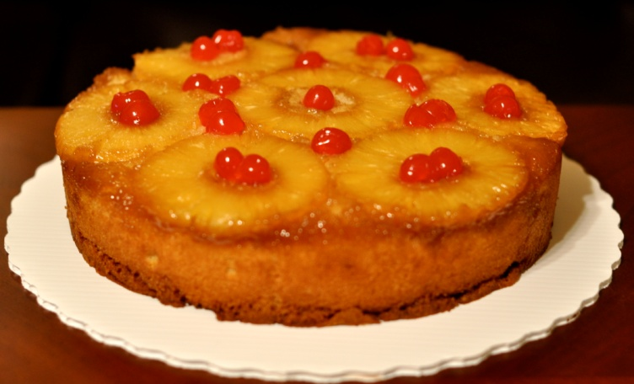
clinging to the bottom—
or was it the top?
Maraschino cherries pop-
Ping with tooth tingling
tangy sweetness,
two thick layers of buttery,
gooey, scrumptiously chewy,
pineapple-licious yellow cake
baked for nobody else but me.

