Standing Tall  by Jamie McKenzie | 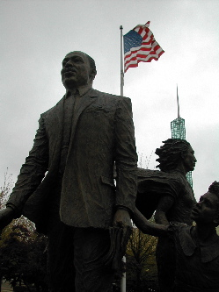
In honor of Martin Luther King
Some kings rule their kingdoms sitting down
Surrounded by luxury, soft cushions and fans
But this King stood strong
stood proud
stood tall
When the driver told Rosa
"Move to the back of the bus!"
When the waiter told students
"We don't serve your kind!"
When the Mayor told voters
"Your vote don't count!"
And when the sheriff told marchers
"Get off our streets!"
using fire hoses, police dogs and cattle prods
to move them along
This King stood strong
stood proud
stood tall
Speaking of peace
of love
and children
hand in hand
free at last
free at last
And when some spit out hate
He stood there smiling
Spreading love
Until it rolled like the sea across the land
Sweeping away Jim Crow
Breaking down the walls
Ringing the bell
Joyfully
For Freedom
Until
Standing on the mountain top
They shot him
Coldly
Hoping to see him fall
Hoping to put him away
To bring him low
But this King
even in death
even today
stands strong
stands proud
stands tall
And we remember
When some yelled for violence
For angry revenge
An eye for an eye
And a tooth for a tooth
He stood his ground
Preaching peace

