If I Were the Equator
Kathryn Madeline Allen

If I were the equator
I would have an attitude.
I’d boast the most about my no degrees of latitude.
I’d say, though there are other lines who run from east to west,
with nearly 25,000 miles I clearly am the best.
My equidistance from the poles,
I’d mention with a laugh,
makes me the one – the only one – who
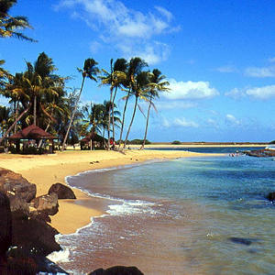
splits the globe in half.
Smack dab
between the Tropics
with the sun high up above,
indeed,
I’d plead,
what on Earth could there be
about me not to love?

